UNITED STATES
SECURITIES AND EXCHANGE COMMISSION
Washington, D.C. 20549

FORM 10-K/A

(Amendment No. 1)

(Mark One)

☒ | ANNUAL REPORT PURSUANT TO SECTION 13 OR 15(d) OF THE SECURITIES EXCHANGE ACT OF 1934

For the fiscal year ended December 31, 2022

OR

☐ | TRANSITION REPORT PURSUANT TO SECTION 13 OR 15(d) OF THE SECURITIES EXCHANGE ACT OF 1934ed

For the transition period from

Commission file number 001-40730

DRAGONFLY ENERGY HOLDINGS CORP.

(Exact name of registrant as specified in its charter)

Nevada |  | 85-1873463
(State or other jurisdiction of  incorporation or organization) |  | (I.R.S. Employer  Identification No.)
1190 Trademark Drive, #108
Reno, Nevada |  | 89521
(Address of Principal Executive Offices) |  | (Zip Code)

(775) 622-3448
(Registrant’s telephone number, including area code)

Securities registered pursuant to Section 12(b) of the Act:

Title of each class |  | Trading Symbol(s) |  | Name of each exchange on which registered
Common stock, par value $0.0001 per share |  | DFLI |  | The Nasdaq Global Market
Redeemable Warrants, exercisable for common stock at an exercise price of $11.50 per share, subject to adjustment |  | DFLIW |  | The Nasdaq Capital Market

Securities registered pursuant to Section 12(g) of the Act: None.

Indicate by check mark if the registrant is a well-known seasoned issuer, as defined in Rule 405 of the Securities Act. Yes ☐ No ☒

Indicate by check mark if the registrant is not required to file reports pursuant to Section 13 or Section 15(d) of the Act. Yes ☐ No ☒

Indicate by check mark whether the registrant: (1) has filed all reports required to be filed by Section 13 or 15(d) of the Securities Exchange Act of 1934 during the preceding 12 months (or for such shorter period that the registrant was required to file such reports); and (2) has been subject to such filing requirements for the past 90 days. Yes ☒ No ☐

Indicate by check mark whether the registrant has submitted electronically every Interactive Data File required to be submitted pursuant to Rule 405 of Regulation S-T during the preceding 12 months (or for such shorter period that the registrant was required to submit such files). Yes ☒ No ☐

Indicate by check mark whether the registrant is a large accelerated filer, an accelerated filer, a non-accelerated filer, or a smaller reporting company. See the definitions of “large accelerated filer,” “accelerated filer” and “smaller reporting company” in Rule 12b-2 of the Exchange Act. (Check one):

Large accelerated filer | ☐ |  | Accelerated filer | ☐
Non-accelerated filer | ☒ |  | Smaller reporting company | ☒
 |  |  | Emerging growth company | ☒

If an emerging growth company, indicate by check mark if the registrant has elected not to use the extended transition period for complying with any new or revised financial accounting standards provided pursuant to Section 13(a) of the Exchange Act. ☐

Indicate by check mark whether the registrant has filed a report on and attestation to its management’s assessment of the effectiveness of its internal control over financial reporting under Section 404(b) of the Sarbanes-Oxley Act (15 U.S.C. 7262(b)) by the registered public accounting firm that prepared or issued its audit report. ☐

If securities are registered pursuant to Section 12(b) of the Act, indicate by check mark whether the financial statements of the registrant included in the filing reflect the correction of an error to previously issued statements. ☐

Indicate by check mark whether any of those error corrections are restatements that required a recovery analysis of incentive-based compensation received by any of the registrant’s executive officers during the relevant recovery period pursuant to Section 240.10D-1(b). ☐

Indicate by check mark whether the registrant is a shell company (as defined in Rule 12b-2 of the Act). Yes ☐ No ☒

The aggregate market value of voting stock held by non-affiliates of the Registrant on June 30, 2022, based on the closing price of $10.1499 for shares of the registrant’s common stock as reported by the Nasdaq Global Market, was approximately $128.4 million. Shares of common stock beneficially owned by each executive officer, director, and holder of more than 10% of our common stock have been excluded in that such persons may be deemed to be affiliates. This determination of affiliate status is not necessarily a conclusive determination for other purposes.

As of March 21, 2023, there were 45,794,923 shares of the registrant’s common stock, par value $0.0001 per share, issued and outstanding.

Documents incorporated by reference:

None.

Audit Firm ID |  | Auditor Name |  | Auditor Location
243 |  | BDO USA LLP |  | Spokane, Washington

EXPLANATORY NOTE

This Amendment No. 1 on Form 10-K/A (this “Amendment No. 1”) amends the Annual Report on Form 10-K for the fiscal year ended December 31, 2022 (the “2022 Annual Report”) of Dragonfly Energy Holdings Corp. filed with the Securities and Exchange Commission (“SEC”) on April 17, 2023. In this Amendment No. 1, unless the context indicates otherwise, the designations “Dragonfly,” the “Company,” “we,” “us” or “our” refer to Dragonfly Energy Holdings, Corp.

This Amendment No. 1 is being filed solely to include information required by Item 10 - “Directors, Executive Officers and Corporate Governance”, Item 11 - “Executive Compensation”, Item 12 - “Security Ownership of Certain Beneficial Owners and Management and Related Stockholder Matters”, Item 13 - “Certain Relationships and Related Transactions, and Director Independence” and Item 14 - “Principal Accounting Fees and Services” of Part III of Form 10-K. The reference on the cover page of the 2022 Annual Report to the incorporation by reference of portions of our definitive proxy statement into Part III of the 2022 Annual Report is hereby deleted. Items 10, 11, 12, 13 and 14 of Part III of the 2022 Annual Report are amended and restated in their entirety as set forth in this Amendment No. 1. In addition, pursuant to Rule 13a-14(a) of the Securities Exchange Act of 1934, as amended (the “Exchange Act”), we are including with this Amendment No. 1 certain currently dated certifications. We are not including the certifications under Section 906 of the Sarbanes-Oxley Act of 2002 (“Sarbanes-Oxley Act”) as no financial statements are being filed with this Amendment No. 1.

Except as described above, no other amendments are being made to the Annual Report. This Amendment No. 1 does not reflect events occurring after the April 17, 2023 filing of the 2022 Annual Report or modify or update the disclosure contained in the 2022 Annual Report in any way other than as required to reflect the amendments discussed above and reflected below. Accordingly, this Amendment No. 1 should be read in conjunction with the 2022 Annual Report and our other filings with the SEC.

i

TABLE OF CONTENTS

 |  | PAGE
 | PART III | 1
Item 10. | Directors, Executive Officers and Corporate Governance | 1
Item 11. | Executive Compensation | 6
Item 12. | Security Ownership of Certain Beneficial Owners and Management and Related Stockholder Matters | 10
Item 13. | Certain Relationships and Related Transactions, and Director Independence | 13
Item 14. | Principal Accounting Fees and Services | 18
 | PART IV | 19
Item 15. | Exhibits and Financial Statement Schedules | 19

ii

PART III

ITEM 10. Directors, Executive Officers and Corporate Governance.

The following table provides information regarding our executive officers and members of our Board of Directors (the “Board”) with their respective ages as of April 17, 2023:

Name |  | Age |  | Position(s) Held With Dragonfly
Denis Phares |  | 50 |  | President, Chief Executive Officer and Chairman of the Board
John Marchetti |  | 52 |  | Chief Financial Officer
Tyler Bourns |  | 34 |  | Chief Marketing Officer
Luisa Ingargiola |  | 55 |  | Lead Independent Director
Rick Parod |  | 69 |  | Director
Karina Montilla Edmonds |  | 51 |  | Director
Brian Nelson |  | 51 |  | Director
Jonathan Bellows |  | 46 |  | Director
Perry Boyle |  | 59 |  | Director

Executive Officers

Dr. Denis Phares has served as our Chief Executive Officer and Chairman of our Board since October 2022. Dr. Phares is the co-founder of Dragonfly Energy Corp., a Nevada corporation (“Legacy Dragonfly”) and has served as Legacy Dragonfly’s Chief Executive Officer and Chairman of the board of directors since 2012. From 2005 until 2012, Dr. Phares served as a faculty member of the Aerospace & Mechanical Engineering Department at the University of Southern California, where he worked extensively on renewable energy technologies and received tenure in 2010. Dr. Phares holds an M.B.A. from the University of Nevada — Reno, a Ph.D. in Engineering from the California Institute of Technology and a B.S. in Physics from Villanova University. Dr. Phares is qualified to serve on our Board based on his substantial business, leadership, and management experience as the Chief Executive Officer and Chairman of our board.

John Marchetti has served as our Chief Financial Officer since October 2022. Mr. Marchetti has also served as the Chief Financial Officer of Legacy Dragonfly since September 2021. Mr. Marchetti has over 20 years of experience in the technology and financial services industries. Previously, Mr. Marchetti served as a Managing Director and senior research analyst at Stifel Financial Corp. from April 2018 until September 2021, where he was focused on communications infrastructure and applied technology markets, including advanced battery technologies. From 2016 to May 2018, Mr. Marchetti served as Senior Vice President for Strategy and Business Development of Cloudbus, a technology research and development company, and, from 2012 to 2015, he served as Chief Strategy Officer and Executive Vice President at Fabrinet, a publicly-traded manufacturing services company. Prior to joining Fabrinet, Mr. Marchetti was a senior equity analyst at Cowen & Co. and Morgan Stanley. Mr. Marchetti also served as an officer in the United States Marine Corps. Mr. Marchetti holds a M.B.A. in Finance from the University of Connecticut, and a B.A. in Political Science from Virginia Tech.

Tyler Bourns has served as our Chief Marketing Officer since November 2022. Prior to the merger and the other transactions contemplated by that certain Agreement and Plan of Merger, dated May 15, 2022, as amended on July 12, 2022, by and among Chardan NexTech Acquisition 2 Corporation (“CNTQ”) Merger Sub and Dragonfly (the “Business Combination”). Business Combination, Mr. Bourns served as the Senior Vice President of Marketing of Legacy Dragonfly from December 2021 through October 2022. Previously, Mr. Bourns is the owner and serves as the present of Bourns Productions Inc., a video production and marketing company focused on content creation, messaging and strategy for various brands across multiple industries, for twelve years. At Bourns Productions Inc., he oversees the day-to-day business of the company, works closely with clients and provides hands on service in the creation of video, photography and graphic content, including for Legacy Dragonfly for the marketing of our Battle Born Batteries brand. In 2018, he was awarded the AAF Reno Ad Person of the Year. A three-time Emmy Award Winner, he has produced and filmed thought-leading content for companies such as Panasonic, GE Energy and Terrasmart. Mr. Bourns has also served on the Board of Directors for the Cordillera International Film Festival since its inception in 2018.

1

Non-Employee Directors

Rick Parod has served as a member of our Board since October 2022. Mr. Parod currently serves as the CEO of AdeptAg, a company that serves the controlled environment agriculture market. Prior to AdeptAg, Mr. Parod was the President and CEO and a director of the Lindsay Corporation, a leading global manufacturer and distributor of irrigation and infrastructure equipment and technology, from 2000 to 2017. From 1997 to 2000, Mr. Parod served as the Vice President and General Manager of the Irrigation Division of The Toro Company, a leading worldwide provider of outdoor turf, landscape, underground utility construction, irrigation and related equipment. Mr. Parod has also served as a director and as a member of the audit committee, compensation committee and nominating and corporate governance committee of Alamo Group Inc., a publicly listed company focusing on design, manufacturing, distribution, and service of equipment for infrastructure maintenance and agriculture, since December 2017 as well as a director of Raven Industries, Inc. from December 2017 until its acquisition by CNH Industrial N.V. in June 2022. Mr. Parod is qualified to serve on our Board based on his experience in manufacturing operations, product development and sales and marketing.

Karina Montilla Edmonds, Ph.D. has served as a member of our Board since October 2022. Dr. Edmonds currently serves as the Senior Vice President and Global Head of Academies and University Alliances at SAP SE, a leading producer of enterprise software for the management of business operations. Prior to joining SAP SE in April 2020, Dr. Edmonds served as the University Relations Lead for Google Cloud at Google from May 2017 through March 2020, where she facilitated research collaborations in AI. Before her time at Google, Dr. Edmonds served at the California Institute of Technology as Executive Director for Institute Corporate Relations from April 2013 through April 2016. In April 2010, Dr. Edmonds was appointed as the U.S. Department of Energy’s first Technology Transfer Coordinator, and she served in that position until April 2013. She has also held positions at the Jet Propulsion Laboratory, a NASA field center and leader in robotic space exploration, as Director for Jet Propulsion Laboratory Technology Transfer and at TRW, Inc. (now Northrop Grumman Corporation, a publicly listed multinational aerospace and defense technology company), as a Principal Investigator. Dr. Edmonds holds a B.S. in Mechanical Engineering from the University of Rhode Island and an M.S. and Ph.D. in Aeronautical Engineering, with a minor in Materials Science, from the California Institute of Technology. Dr. Edmonds is also a registered patent agent with the U.S. Patent and Trademark Office. Dr. Edmonds serves on the boards of the University of Rhode Island and the National Science Foundation’s Directorate for Engineering Advisory Committee, and has previously served on the boards of the Institute for Pure and Applied Mathematics at the University of California, Los Angeles, ConnectED California and the University of Rhode Island Foundation. Dr. Edmonds is qualified to serve on our Board based on her industry leadership and expertise in technology transfer and commercialization.

Brian Nelson has served as a member of our Board since October 2022. Prior to the Business Combination, Mr. Nelson served on the board of directors of Legacy Dragonfly from April 2022 to October 2022. Mr. Nelson has served as the Chief Executive Officer of Precision Surfacing Solutions Group (formerly known as the Lapmaster Group) since 2003 and as the President since 2002. Mr. Nelson was hired in the sales department of Lapmaster in 1996 and he purchased the company in 2003. In 1996, Mr. Nelson served as a Sales Engineer for TII Technical Education Systems, and from 1993 to 1995, he served as a Staff Engineer for Rust Environment & Infrastructure. Mr. Nelson holds an M.B.A. in Entrepreneurship from the DePaul University Charles H. Kellstadt School of Business and a B.S. in Civil & Environmental Engineering from Marquette University. He is a member of the Association of Manufacturing Technology and Young President’s Organization. Mr. Nelson is qualified to serve on our Board based on his years of business experience as President and Chief Executive Officer of Precision Surfacing Solutions Group and Lapmaster.

Jonathan Bellows has served as a member of our Board since October 2022. Mr. Bellows currently serves as President of KORE Power, which acquired Northern Reliability in March 2022. He has served as President and Chief Executive Officer of Northern Reliability since April 2015. KORE Power is a publicly-traded fully integrated energy storage manufacturing company, combining Northern Reliability’s energy storage technology with KORE Power’s cell manufacturing capabilities. Mr. Bellows is also President and Chief Executive Officer of Nomad Transportable Power Systems, a provider of commercial and industrial-scale mobile energy storage units, which was founded by affiliates of KORE Power and Northern Reliability. Previously, Mr. Bellows was vice resident of business and sales at Sovernet Communications, a fiber-optic bandwidth infrastructure services provider, from 2005 to 2015. Mr. Bellows graduated Northern Vermont University-Johnson in 1998, where he earned his B.A. in History. Mr. Bellows is qualified to serve on our Board based on his energy storage industry expertise and operating and leadership experience.

2

Luisa Ingargiola has served as a member of our Board since October 2022. Prior to the Business Combination, Ms. Ingargiola served on the board of directors of Legacy Dragonfly from August 2021 to October 2022. Since February 2017, Ms. Ingargiola has served as Chief Financial Officer of Avalon GloboCare Corp., a publicly listed bio-tech health care company. Prior to joining Avalon GloboCare Corp., Ms. Ingargiola served as the Chief Financial Officer and Co-Founder of MagneGas Corporation from 2007 to 2016. Ms. Ingargiola has also served as a board director and audit committee chair for various over-the-counter and Nasdaq companies. Ms. Ingargiola has served as a member of the board of directors and as Audit Committee Chair for Progress Acquisition Corporation since November 2020, as a member of the board of directors and as Audit Committee Chair for AgEagle Aerial Systems since March 2019, and as a member of the board of directors and as Audit Committee Chair for Electra Meccanica since March 2018. Ms. Ingargiola holds a M.B.A. in Health from the University of South Florida and a B.S. in Finance from Boston University. Ms. Ingargiola is qualified to serve on our Board based on her previous roles serving as Chief Financial Officer for multiple companies and extensive experience serving on multiple boards of directors for Nasdaq companies.

Perry Boyle has served as a member of our Board since October 2022. Prior to the Business Combination, he served on the board of directors of CNTQ from August 2021 to October 2022. Previously, Mr. Boyle was with Point72 and its affiliates and predecessors from 2004 through his retirement in March 2020. He helped lead Point72’s launch as a registered investment advisor, raising over $6 billion in external capital. He originally joined S.A.C. Capital Advisors in 2004 as the firm’s first director of research. In January 2013 he became head of equities and, in January 2015, he became head of discretionary investing at Point72. From June 2016 through December 2017 he served as the President and Chief Investment Officer of Stamford Harbor Capital, L.P., a company owned by businessman Steven A. Cohen. He returned to Point72 in January 2018. Prior to joining S.A.C., Mr. Boyle was a founding partner of Thomas Weisel Partners from 1999 until 2004, and a managing director at Alex Brown & Sons from 1992 – 1999. He began his career as an investment banker with Salomon Brothers Inc. Mr. Boyle is a member of the advisory board of the Center for a New American Security, and a director of The US Friends of the International Institute for Strategic Studies. He was a 2018 and 2019 delegate from the IISS to the Shangri-La Dialogue in Singapore. He is a council member of the Hoover Institution and a Lionel Curtis member of Chatham House. Mr. Boyle currently serves as the Chairman of the BOMA Project, a poverty graduation program for women, youth, and displaced persons in sub-Saharan Africa. He is also the President of the Affordable Housing Coalition of Ketchum, an advocacy organization for workforce housing in Ketchum, Idaho. He received his B.A. in Economics from Stanford University, his M.B.A. from Dartmouth College and a M.A. from the Fletcher School of Law and Diplomacy at Tufts University. Mr. Boyle is qualified to serve on our Board based on his industry leadership and capital markets experience from research to fundraising.

Board Composition

Our Board currently consists of three classes of a total of seven directors. Our directors each serve staggered three-year terms with one class being elected at each year’s annual meeting of stockholders, as follows:

 | ● | Class A, which consists of Rick Parod and Karina Edmonds, whose terms will expire at the 2023 annual meeting of stockholders;
 | ● | Class B, which consists of Brian Nelson and Jonathan Bellows, whose terms will expire at the 2024 annual meeting of stockholders; and
 | ● | Class C, which consists of Denis Phares, Luisa Ingargiola and Perry Boyle, whose terms will expire at the 2025 annual meeting of stockholders.

3

We have no formal policy regarding board diversity. Our priority in selecting our board members is the identification of members who will further the interests of our stockholders through their established record of professional accomplishment, the ability to contribute positively to the collaborative culture among board members, knowledge of our business and understanding of the competitive landscape.

The Board oversees our business and monitors the performance of our management. In accordance with our corporate governance procedures, the Board does not involve itself in our day-to-day operations. Our executive officers and management oversee our day-to-day operations. Our directors fulfill their duties and responsibilities by attending meetings of the Board, which are usually held on at least a quarterly basis. Our directors also discuss business and other matters with other key executives and our principal external advisers (legal counsel, auditors, financial advisors and other consultants).

Board Committees

Our Board has three standing committees — an audit committee, a compensation committee, and a nominating and corporate governance committee. Copies of the charters for each committee are posted under the “Investors” tab on our website, which is located at https://dragonflyenergy.com/.

Audit Committee

The Board has formed an Audit Committee, which currently consists of Luisa Ingargiola, Rick Parod, and Perry Boyle. Each member of the Audit Committee is “independent” as that term is defined under the applicable rules of the SEC and Nasdaq. The Board has determined that each Audit Committee member has sufficient knowledge in financial and auditing matters to serve on the Audit Committee. In addition, our Board has determined that Ms. Ingargiola qualifies as an audit committee financial expert within the meaning of SEC regulations and the Nasdaq Marketplace Rules.

Luisa Ingargiola serves as the chair of the Audit Committee. The Audit Committee oversees and monitors our financial reporting process and internal control system, reviews and evaluates the audit performed by our registered independent public accountants and reports to our Board any substantive issues found during the audit. The Audit Committee will be directly responsible for the appointment, compensation and oversight of the work of our registered independent public accountants. The Audit Committee reviews and approves all transactions with affiliated parties. The Board has adopted a written charter for the Audit Committee.

Compensation Committee

The Board has formed a Compensation Committee which consists of Luisa Ingargiola, Brian Nelson, and Rick Parod, all of whom are independent (as that term is defined under the Nasdaq Marketplace Rules). Brian Nelson serves as the chair of the Compensation Committee. The Compensation Committee assists the Board in fulfilling its oversight responsibilities relating to (i) corporate governance practices and policies and (ii) compensation matters, including compensation of the directors and senior management of the Company and the administration of compensation plans of the Company. Our Board determined that each of the members of the compensation committee are a non-employee director, as defined in Rule 16b-3 promulgated under the Exchange Act and satisfies the independence requirements of Nasdaq.

Nominating and Corporate Governance Committee

The Board has formed a Nominating and Corporate Governance Committee, which currently consists of Karina Montilla Edmonds, Brian Nelson and Jonathan Bellows, all of whom are independent (as that term is defined under the Nasdaq Marketplace Rules). Karina Montilla Edmonds serves as the chair of the Nominating and Corporate Governance Committee. The Nominating and Corporate Governance Committee assesses potential candidates to fill perceived needs on the Board for required, skills, expertise, independence and other factors.

4

Nomination of Directors

The Nominating and Corporate Governance Committee of the Board assesses potential candidates to fill perceived needs on the Board of Directors for required skills, expertise, independence and other factors. A director candidate recommended by our stockholders will be considered in the same manner as a nominee recommended by a Board member, management or other sources. Stockholders wishing to recommend a candidate for nomination should contact our Secretary in writing at the Secretary of Dragonfly at 1190 Trademark Drive, #108, Reno, Nevada 89521. Our Nominating and Corporate Governance Committee has discretion to decide which individuals to recommend for nomination as directors.

Board Leadership Structure and Role in Risk Oversight

Periodically, our Board will assess the roles of Chairman and Chief Executive Officer, and the Board leadership structure to ensure the interests of Dragonfly and our stockholders are best served. Our Board believes the current combination of the two roles is satisfactory at present. Dr. Phares, as our President, Chief Executive Officer and Chairman, has extensive knowledge of all aspects of Dragonfly and our business. Our Board has appointed Ms. Ingargiola as Lead Independent Director. We have no policy requiring the combination or separation of leadership roles and our governing documents do not mandate a particular structure. This has allowed, and will continue to allow, our Board the flexibility to establish the most appropriate structure for the Company at any given time.

Our Board is primarily responsible for overseeing our risk management processes. The Board receives and reviews periodic reports from management, auditors, legal counsel, and others, as considered appropriate regarding the Company’s assessment of risks. The Board focuses on the most significant risks facing the Company and the Company’s general risk management strategy, and also ensures that risks undertaken by the Company are consistent with the Board’s risk strategy. While the Board oversees the Company’s risk management, management is responsible for day-to-day risk management processes. We believe this division of responsibilities is the most effective approach for addressing the risks facing the Company and that our Board leadership structure supports this approach.

Family Relationships

There are no family relationships among any of our directors or executive officers.

Code of Ethics

We have adopted a Code of Business Conduct and Ethics that applies to all of our executive officers, financial and accounting officers, our directors, our financial managers and all of our employees. The Board is committed to a high standard of corporate governance practices and, through its oversight role, encourages and promotes a culture of ethical business conduct. A copy of our Code of Business Conduct and Ethics is posted under the “Investors” tab on our website, which is located at https://dragonflyenergy.com/.

Delinquent Section 16(a) Reports

Section 16(a) of the Exchange Act requires the Company’s directors, executive officers and persons who own more than 10% of a registered class of the Company’s securities to file with the SEC initial reports of ownership and reports of changes in ownership of common stock and other equity securities of the Company. Directors, executive officers and greater than 10% stockholders are required by SEC regulation to furnish the Company with copies of all Section 16(a) reports they file. To our knowledge, based solely on the review of the copies of these forms furnished to us and representations that no other reports were required, the Company believes that all forms required to be filed under Section 16 of the Exchange Act for the year ended December 31, 2022 were filed timely.

5

ITEM 11. EXECUTIVE COMPENSATION.

Our Board has formed a Compensation Committee. The Compensation Committee is responsible for reviewing and approving management compensation, including salaries, bonuses, and equity compensation. We seek to provide competitive compensation arrangements that attract and retain key talent necessary to achieve our business objectives.

Summary Compensation Table

The following table presents information regarding the total compensation awarded to, earned by, or paid to each person serving as our Chief Executive Officer during the fiscal year ended December 31, 2022, the two most highly-compensated executive officers (other than the Chief Executive Officer) who were serving as executive officers during the fiscal years ended December 31, 2022 and December 31, 2021, and up to two additional individuals for whom disclosure would have been provided but for the fact that such individuals were not serving as an executive officer as of December 31, 2022 for services rendered in all capacities to us for the fiscal year ended December 31, 2022. These individuals are our named executive officers (“NEOs”) for fiscal 2022.

 |  |  |  |  |  |  |  |  |  |  |  |  |  |  |  |  |  |  |  |  |  |  |  |  |  | Non-Qualified
 |  |  |  |  |  |  |  |  |  |  |  |  |  |  |  |  |  |  |  |  |  | Non-Equity |  |  |  | Deferred
 |  |  |  |  |  |  |  |  |  |  |  |  |  | Stock |  |  |  | Option |  |  |  | Incentive Plan |  |  |  | Compensation |  |  |  | All Other
Name and |  |  |  |  |  | Salary |  |  |  | Bonus |  |  |  | Awards |  |  |  | Awards |  |  |  | Compensation |  |  |  | Earnings |  |  |  | Compensation |  |  |  | Total
Principal Position |  | Year |  |  |  | ($) |  |  |  | ($)(1) |  |  |  | ($)(2) |  |  |  | ($)(3) |  |  |  | ($) |  |  |  | ($) |  |  |  | ($)(4) |  |  |  | ($)
Dr. Denis Phares |  |  | 2022 |  |  |  | 682,000 |  |  |  | 806,207 |  |  |  | 1,531,545 |  |  |  | — |  |  |  | — |  |  |  | — |  |  |  | — |  |  |  | 3,019,752
Chief Executive Officer |  |  | 2021 |  |  |  | 579,593 |  |  |  | 362,137 |  |  |  | — |  |  |  | — |  |  |  | — |  |  |  | — |  |  |  | 22,234 |  |  |  | 963,964
Sean Nichols(5) |  |  | 2022 |  |  |  | 598,462 |  |  |  | 655,587 |  |  |  | — |  |  |  | — |  |  |  | — |  |  |  | — |  |  |  | 157,693 |  |  |  | 1,411,742
Former Chief Operating Officer |  |  | 2021 |  |  |  | 579,593 |  |  |  | 362,137 |  |  |  | — |  |  |  | — |  |  |  | — |  |  |  | — |  |  |  | 20,244 |  |  |  | 961,974
John Marchetti(6) |  |  | 2022 |  |  |  | 316,153 |  |  |  | 769,366 |  |  |  | 645,998 |  |  |  | — |  |  |  | — |  |  |  | — |  |  |  | 11,057 |  |  |  | 1,742,574
Chief Financial Officer |  |  | 2021 |  |  |  | 91,154 |  |  |  | 82,000 |  |  |  | — |  |  |  | 399,999 |  |  |  | 283,249 |  |  |  | — |  |  |  | — |  |  |  | 856,402
Nicole Harvey(7) |  |  | 2022 |  |  |  | 242,461 |  |  |  | 80,000 |  |  |  | 561,000 |  |  |  | — |  |  |  | — |  |  |  | — |  |  |  | — |  |  |  | 883,461
Former Chief Legal Officer |  |  | 2021 |  |  |  | 66,346 |  |  |  | 25,000 |  |  |  | — |  |  |  | 341,621 |  |  |  | — |  |  |  | — |  |  |  | — |  |  |  | 432,967

 | (1) | The amounts reported in this column represent discretionary bonuses awarded to each executive for performance during the fiscal years ended December 31, 2022 and December 31, 2021.
 | (2) | The amounts reported in this column reflect the grant date fair value of restricted stock awards granted to the NEOs for performance during the fiscal year ended December 31, 2022 under the 2022 Plan (as defined below) and are accounted for in accordance with FASB ASC Topic 718. Please see the section titled “Stock-Based Compensation” beginning on page F-11 of our Notes to Consolidated Financial Statements included elsewhere in this Annual Report for a discussion of the relevant assumptions used in calculating these amounts.
 | (3) | The amounts reported in this column reflect the grant date fair value of stock option awards granted to the NEOs during 2021 under our stock incentive plans and are accounted for in accordance with FASB ASC Topic 718. Please see the section titled “Stock-Based Compensation” beginning on page F-11 of our Notes to Consolidated Financial Statements included elsewhere in this Annual Report for a discussion of the relevant assumptions used in calculating these amounts.
 | (4) | This amount reflects our matching contribution to the executive’s account under our 401(k) plan.
 | (5) | On November 4, 2022, we announced that Mr. Nichols would be stepping down as our Chief Operating Officer on November 7, 2022.
 | (6) | Mr. Marchetti commenced employment as Legacy Dragonfly’s Chief Financial Officer on September 6, 2021.
 | (7) | Ms. Harvey’s employment with us ended on April 26, 2023.

The Compensation Committee has engaged Compensia, Inc. as our independent compensation consultant. In 2022, Compensia, Inc. viewed both executive and director compensation and did not provide us any other services. Compensia, Inc. reported directly to the Compensation Committee and provided guidance on trends in executive and non-employee director compensation, the development of specific executive compensation programs, the composition of our compensation peer group and other matters as directed by the Compensation Committee.

6

Executive Employment Agreements

We have entered into employment agreements, dated as of October 11, 2022 with each of Dr. Phares, Ms. Nicole Harvey and Mr. Marchetti. Each agreement provides for a three-year initial employment term, with automatic three-year renewal terms thereafter, subject to 90 days’ notice of non-renewal by either party. Each agreement also provides for the executive to receive an annual base salary (Dr. Phares — $622,000; Ms. Harvey — $334,000; Mr. Marchetti — $370,000) and to be eligible for an annual bonus of up to a specified percentage of the executive’s base salary (Dr. Phares — 100%; Ms. Harvey — 46%; Mr. Marchetti — 63%). The executive is generally eligible for an annual bonus only if he or she remains employed with us through the date the bonus is paid (or if the executive’s employment terminates due to his or her death or disability during the year). The executive is also eligible to receive a long-term incentive award each fiscal year with a grant-date value not less than a dollar amount specified in the agreement (Dr. Phares — $1,532,000; Ms. Harvey — $561,000; Mr. Marchetti — $646,000), with the terms and conditions of each such award to be determined by the compensation committee. Each agreement also includes non-competition and non-solicitation covenants that apply for 12 months following the executive’s termination of employment, and certain confidentiality and other covenants.

If the executive’s employment is terminated by us without “cause” or by the executive for “good reason” (as such terms are defined in the employment agreement) and other than a termination in connection with a change in control as described below, the executive would be entitled to receive (i) cash severance equal to 1.5 times the executive’s annual base salary (in the case of Dr. Phares and Ms. Harvey) or 1.0 times the executive’s annual base salary (in the case of Mr. Marchetti), payable in installments over two years following the termination date, (ii) reimbursement of monthly COBRA premiums for the executive and his or her dependents for up to 18 months (in the case of Dr. Phares) or 12 months (in the case of Ms. Harvey and Mr. Marchetti), and (iii) vesting in full of any time-based equity awards granted by us to the executive (with any performance-based awards to remain eligible to vest following termination if the applicable performance conditions are satisfied). In such circumstances, Dr. Phares would also be entitled to receive payment of 1.5 times the annual bonus he would have received for the fiscal year in which his termination occurs, pro-rated to reflect the portion of the fiscal year he was employed prior to his termination.

If, during the period commencing three months before a change in control of the Company and ending 12 months after a change in control, the executive’s employment is terminated by us without cause (or as a result of us not renewing the term of the agreement) or by the executive for good reason, the executive would be entitled to receive the severance benefits described in the preceding paragraph (except that the cash severance would be 1.5 times the executive’s base salary for Ms. Harvey and Mr. Marchetti, the severance in each case would be payable in a lump sum rather than installments, and the pro-rated bonus provision for Dr. Phares described above would not apply). In addition, the executive’s outstanding stock options granted by us would fully vest and be exercisable for the remainder of the term of the option. In the event any of the executive’s benefits under the agreement would be subject to an excise tax as a “parachute payment” under U.S. tax laws, the executive would be entitled to an additional payment equal to the sum of the excise tax and any additional amount necessary to put the executive in the same after-tax position as if no excise tax has been imposed.

In each case, the executive’s right to receive the severance benefits described above is subject to his or her providing a release of claims to us and his or her continued compliance with the restrictive covenants in favor of us in the agreement.

On November 4, 2022, we announced that Sean Nichols, our Chief Operating Officer, would be stepping down to pursue other interests. His last day of employment was November 7, 2022. We have entered into a separation and release agreement (the “Separation Agreement”) with Mr. Nichols that became effective and fully irrevocable on November 2, 2022. Pursuant to the Separation Agreement, Mr. Nichols received a cash payment of $100,000 in one installment in December 2022 and will receive a cash payment of $1,000,000 in 24 monthly installments commencing in December 2022. Mr. Nichols’ outstanding equity awards granted by us will fully vest and, in the case of options, will be exercisable for 12 months following his termination date. The Separation Agreement also provides we will pay a portion of Mr. Nichols’ premiums to continue participation in our health insurance plans for up to 18 months following his termination. The Separation Agreement includes a general release of claims by Mr. Nichols and certain restrictive covenants in favor of us, including non-competition and non-solicitation covenants for 12 months following his termination date.

7

On February 24, 2023, we entered into an amended and restated employment agreement with Mr. Marchetti to provide that Mr. Marchetti will receive a minimum annual bonus of $175,000 for the fiscal year ending December 31, 2023. All other terms of the amended and restated Agreement remain the same as the original agreement.

On April 26, 2023, Ms. Harvey’s employment with us ended and her employment agreement would be deemed terminated as of that date by us without cause for purposes of determining severance thereunder.

Outstanding Equity Awards at Fiscal Year-End

The following table provides information regarding outstanding options to acquire our common stock held by each of the NEOs as of December 31, 2022, including the vesting dates for the portions of these awards that had not vested as of that date. The NEO did not hold any other outstanding equity awards as of that date.

 |  | Option Awards
 |  |  |  |  |  |  |  |  |  | Equity
 |  |  |  |  |  |  |  |  |  | Incentive
 |  |  |  |  |  |  |  |  |  | Plan Awards:
 |  | Number of |  |  |  | Number of |  |  |  | Number of
 |  | Securities |  |  |  | Securities |  |  |  | Securities
 |  | Underlying |  |  |  | Underlying |  |  |  | Underlying
 |  | Unexercised |  |  |  | Unexercised |  |  |  | Unexercised |  |  |  | Option |  |  |  | Option
 |  | Options (#) |  |  |  | Options (#) |  |  |  | Unearned |  |  |  | Exercise |  |  |  | Expiration
Name |  | Exercisable |  |  |  | Unexercisable |  |  |  | Options (#) |  |  |  | Price ($) |  |  |  | Date
Dr. Denis Phares |  |  | 118,208 |  |  |  | 59,108 | (1) |  |  | — |  |  |  | 0.32 |  |  |  | 12/5/2029
Sean Nichols |  |  | 177,316 |  |  |  | — | (1) |  |  | — |  |  |  | 0.32 |  |  |  | 11/7/2023
John Marchetti |  |  | 93,587 | (2) |  |  | 142,831 |  |  |  | — |  |  |  | 2.89 |  |  |  | 9/13/31
Nicole Harvey |  |  | 51,497 |  |  |  | 57,257 |  |  |  | — |  |  |  | 2.89 |  |  |  | 10/22/2031

 | (1) | The unvested portion of this option vests in 20 monthly installments from January 12, 2022 and August 12, 2023.
 | (2) | The unvested portion of this option vests as to 25% of the option on September 10, 2022 and as to 75% of the option in 36 monthly installments from October 10, 2022 through September 10, 2025.

2022 Equity Grants
During 2022, Mr. Marchetti received an option to purchase 200,000 shares of our common stock at a price of $3.41 per share. This option was granted under the Legacy Dragonfly 2021 Stock Incentive Plan and vests as to 25% of the option on the first anniversary of the vesting start date established by our board of directors for the option and as to the remaining 75% of the option in monthly installments over the three-year period thereafter, subject to Mr. Marchetti’s continued service with us through the applicable vesting date.

For services performed during the year ended December 31, 2022, on February 10, 2023, Dr. Phares was granted 204,266 restricted stock units (“RSUs”), Mr. Marchetti was granted 86,133 RSUs, and Ms. Harvey was granted 74,800 RSUs. Each grant vested in full on the date of grant.

Director Compensation

In connection with the closing of the Business Combination (the “Closing”), we adopted a policy that provides for cash and equity compensation for members of our Board of directors who are not employed by us or any of our subsidiaries (our “Non-Employee Directors”). The policy provides that each Non-Employee Director is entitled to receive the following cash compensation for board service, as applicable:

 | ● | $58,800 annual retainer for service as a Board member;
 | ● | $20,000 additional annual retainer for service as Lead Independent Director; and
 | ● | $20,000 additional annual retainer for service as Chair of the Audit Committee, $15,000 additional annual retainer for service as Chair of the Compensation Committee, and $10,000 additional annual retainer for service as Chair of the Nominating and Corporate Governance Committee.

Under the policy, directors are not paid fees for service as members on any of our standing committees, apart from the Chair fees discussed above. Further, directors must attend at least 75% of all meetings of the Board and all meetings of each committee on which the director sits to be eligible to receive any of the retainers specified above. These annual retainers are paid on a quarterly basis and pro-rated if the director commences service in the applicable position after the start of a fiscal quarter.

8

Our Board also has discretion under the director compensation policy to grant Non-Employee Directors equity-based awards under our Dragonfly Energy Holdings 2022 Equity Incentive Plan (“2022 Plan”) (or any successor equity compensation plan approved by our stockholders). It is currently expected that Non-Employee Directors will receive an award of options or restricted stock units with a value of $300,000 upon their initial appointment to the Board and an award of options or restricted stock units with a value of $100,000 on an annual basis thereafter. For each award, the Board will determine at the time of grant the methodology for converting the foregoing dollar amounts to shares and the vesting schedule. The Board may approve other grants of equity-based awards to Non-Employee Directors from time to time, on such terms as the Board may determine and subject to the applicable provisions of our equity compensation plan then in effect.

Under the policy, Non-Employee Directors are entitled to reimbursement from us for their reasonable travel (including airfare and ground transportation), lodging and meal expenses incident to meetings of the Board or committees thereof or in connection with other Board-related business.

Our Board may change the terms of our director compensation policy from time to time.

Effective on the October 7, 2022, we granted each of our Non-Employee Directors then serving of the Board (i.e. Jonathan Bellows, Perry Boyle, Karina Edmonds, Luisa Ingargiola, Brian Nelson, and Rick Parod) an award of 30,000 restricted stock units under the 2022 Plan that are eligible to vest on the first anniversary of the grant date, subject to the director’s continued service on the Board through the vesting date.

Director Compensation Table — Fiscal 2022

The following table sets forth certain information concerning compensation paid to our Non-Employee Directors for services on our board during the year ended December 31, 2022. Messrs. Phares and Nichols did not receive any additional compensation for their service on our board during the year ended December 31, 2022.

Name |  | Fees Earned or Paid in Cash ($) |  |  |  | Stock Awards ($)(1) |  |  |  | Option Awards ($)(1) |  |  |  | All Other Compensation ($) |  |  |  | Total ($)
Jonathan Bellows |  |  | 13,741 |  |  |  | 420,000 |  |  |  | — |  |  |  | — |  |  |  | 433,741
Perry Boyle |  |  | 13,741 |  |  |  | 420,000 |  |  |  | — |  |  |  | — |  |  |  | 433,741
Karina Montilla Edmonds, Ph.D. |  |  | 16,078 |  |  |  | 420,000 |  |  |  | — |  |  |  | — |  |  |  | 436,078
Luisa Ingargiola |  |  | 23,089 |  |  |  | 420,000 |  |  |  | — | (2) |  |  | — |  |  |  | 443,089
Brian Nelson |  |  | 17,247 |  |  |  | 420,000 |  |  |  | 245,401 | (3) |  |  | — |  |  |  | 682,648
Rick Parod |  |  | 13,741 |  |  |  | 420,000 |  |  |  | — |  |  |  | — |  |  |  | 433,741

(1) The amount reported in this column reflects the grant date fair value of the stock option and/or RSUs granted to the Non-Employee Directors during the year ended December 31, 2022 under the 2022 Plan as described above and is accounted for in accordance with FASB ASC Topic 718. Please see the section titled “Stock-Based Compensation” beginning on page F-11 of our Notes to Consolidated Financial Statements included in our Annual Report. As of December 31, 2022, each Non-Employee Director held 30,000 unvested RSUs.
(2) The aggregate number of shares of common stock underlying stock options and unvested RSUs outstanding as of December 31, 2022 held by Ms. Ingargiola was 127,521.
(3) The stock option awards to purchase 70,925 shares of our common stock were granted to Mr. Nelson on May 9, 2022 and vest in 36 equal monthly installments beginning on May 15, 2022.

9

ITEM 12. Security Ownership of Certain Beneficial Owners and Management and Related Stockholder Matters.

The following table sets forth certain information as of April 17, 2023, with respect to the beneficial ownership of common stock by the following:

 | ● | Each other person, or group of affiliated persons, known by us to beneficially own more than 5% of any class of our outstanding shares of common stock;
 | ● | each of our named executive officers;
 | ● | each of our current directors; and
 | ● | all of our executive officers and directors as a group.

Information relating to beneficial ownership of the voting securities by our principal stockholders and management is based upon each person’s information using “beneficial ownership” concepts under the SEC rules. Under these rules, a person is deemed to be a beneficial owner of a security if that person has or shares voting power, which includes the power to vote or direct the voting of the security, or investment power, which includes the power to vote or direct the voting of the security. For purposes of computing the number and percentage of shares beneficially owned by a security holder, any shares which such person has the right to acquire within 60 days of April 17, 2023 (“Presently Exercisable Securities”), are deemed to be outstanding, but those shares are not deemed to be outstanding for the purpose of computing the percentage ownership of any other security holder.

The table reflects 45,820,750 shares common stock outstanding as of April 17, 2023 plus any shares issuable upon exercise of Presently Exercisable Securities held by such person or entity.

Under the SEC rules, more than one person may be deemed to be a beneficial owner of the same securities and a person may be deemed to be a beneficial owner of securities as to which he or she may not have any pecuniary beneficial interest. Except as noted below, ownership consists of sole ownership, voting and investment rights, and the address for each stockholder listed is c/o 1190 Trademark Drive, #108, Reno, Nevada 89521.

Name and Address of Beneficial Owner |  | Amount and  Nature of  Beneficial  Ownership |  |  |  | Percent  of Class
5% Holders:
Dynavolt Technology (HK) Ltd.(1) |  |  | 11,820,900 |  |  |  | 25.80 | %
Chardan NexTech Investments 2 LLC(2)(3) |  |  | 3,030,500 |  |  |  | 6.61 | %
Jonas Grossman(2)(3)(4) |  |  | 3,469,500 |  |  |  | 7.50 | %
Li Gong(5) |  |  | 3,073,434 |  |  |  | 6.60 | %
Named Executive Officers and Directors:
Dr. Denis Phares(6)(7) |  |  | 16,251,136 |  |  |  | 35.35 | %
Sean Nichols(6)(8) |  |  | 3,735,999 |  |  |  | 8.12 | %
Nicole Harvey(9) |  |  | 141,809 |  |  |  | *
John Marchetti(10) |  |  | 189,562 |  |  |  | *
Tyler Bourns (11) |  |  | 58,512 |  |  |  | *
Luisa Ingargiola(12) |  |  | 59,598 |  |  |  | *
Brian Nelson(13) |  |  | 27,594 |  |  |  | *
Perry Boyle |  |  | 22,000 |  |  |  | *
Jonathan Bellows |  |  | 0 |  |  |  | -
Rick Parod |  |  | 0 |  |  |  | -
Karina Montilla Edmonds |  |  | 0 |  |  |  | -
All Executive Officers and Directors as a group (9 persons): |  |  | 20,344,401 |  |  |  | 44.40 | %

10

* Less than one percent.

(1) | Based on the Schedule 13D filed by Dynavolt Technology (HK) Ltd. (“Dynavolt”) on October 12, 2022. The business address of Dynavolt is Flat/Room 02-03 26/F, Bea Tower Millennium City 5, 418 Kwun Tong Road, Kwun Tong, Hong Kong.
(2) | Based on the joint Schedule 13D/A filed by Sponsor and Jonas Grossman on January 9, 2023. Mr. Grossman is the managing member of the Sponsor and the President and managing partner of CCM, an affiliate of the Sponsor. As such, Mr. Grossman may be deemed to have beneficial ownership of the 3,030,500 shares of common stock held directly by Chardan. Mr. Grossman disclaims any beneficial ownership of the reported shares other than to the extent of any pecuniary interest he may have therein, directly or indirectly.
(3) | Excludes 15,000 shares issued to CCM. Mr. Kerry Propper, Mr. Steven Urbach and Mr. Jonas Grossman, are CCM’s Chairman, Chief Executive Officer and President, respectively, and are each Members and Managers of Chardan Securities LLC, which holds a controlling interest in CCM. Mr. Urbach has all investment and voting power over the 15,000 shares held by CCM. The business address of Sponsor, CCM, and Mr. Grossman is 17 State Street, 21st Floor, New York, NY 10004. CCM, an affiliate of the Sponsor and Warrant Holdings, is a broker-dealer and a member of the Financial Industry Regulatory Authority, Inc.
(4) | Includes 439,000 private warrants issuable upon exercise of outstanding warrants within 60 days of the Record Date. Excludes 1,062,386 private warrants, which Warrant Holdings LLC has agreed not to exercise to the extent that Warrant Holdings and its affiliates would be deemed to beneficially own more than 7.5% of the shares of common stock outstanding immediately after giving effect to such exercise. The business address of Warrant Holdings is 17 State Street, 21st Floor, New York, NY 10004.
(5) | Based on the Schedule 13D filed by Li Gong on October 12, 2022. Includes (i) 147,138 shares of common stock held on behalf of the SAKURA GRAT, dated February 11, 2021, of which Mr. Gong is a trustee, (ii) 2,217,042 shares of common stock on behalf of the LML Family Trust, dated January 14, 2019, of which Mr. Gong is a trustee and (iii) 709,254 shares of common stock issuable upon exercise of outstanding stock options exercisable within 60 days of April 17, 2023. The business address of Mr. Gong is 930 Tahoe Blvd. Suite 802, PMB 860, Incline Village, Nevada 89451.
(6) | Excludes 40,000,000 shares of common stock not yet payable as the earnout contingencies have not yet been met and will not be met within 60 days of April 17, 2023.
(7) | Includes (i) 1,217,906 shares held on behalf of the Phares 2021 GRAT dated July 9, 2021, of which Dr. Phares is the trustee, and (ii) 147,760 shares of common stock issuable upon exercise of outstanding stock options exercisable within 60 days of April 17, 2023.
(8) | Based on the Schedule 13D filed by Sean Nichols, our former Chief Operating Officer, on October 12, 2022 and information available to us. Includes 54,393 shares of common stock held on behalf of the Nichols GRAT I dated June 14, 2021, and 3,383,142 shares of common stock held on behalf of the Nichols Living Trust 2015, each of which Mr. Nichols is the trustee. On November 7, 2022, Mr. Nichols resigned from his position as our Chief Operating Officer. Also includes 177,316 shares of common stock issuable upon exercise of outstanding stock options exercisable within 60 days of April 17, 2023.
(9) | Includes 55,188 shares of common stock issuable upon exercise of outstanding stock options exercisable within 60 days of April 17, 2023. On April 26, 2023, Ms. Harvey’s employment with us ended.
(10) | Includes 103,439 shares of common stock issuable upon exercise of outstanding stock options exercisable within 60 days of April 17, 2023.
(11) | Includes 19,953 shares of common stock issuable upon exercise of outstanding stock options exercisable within 60 days of April 17, 2023.
(12) | Includes 59,598 shares of common stock issuable upon exercise of outstanding stock options exercisable within 60 days of April 17, 2023.
(13) | Includes 27,594 shares of common stock issuable upon exercise of outstanding stock options exercisable within 60 days of April 17, 2023.

11

Securities Authorized for Issuance Under Equity Compensation Plans

In connection with our Business Combination, our Board and stockholders adopted the 2022 Plan, which provides for the grant of incentive stock options and non-qualified stock options to purchase shares of our common stock and other types of awards, as well as the Dragonfly Energy Holdings Corp. Employee Stock Purchase Plan (the “ESPP”).

The general purpose of the 2022 Plan is to provide a means whereby eligible employees, officers, non-employee directors and other individual service providers develop a sense of proprietorship and personal involvement in our development and financial success, and to encourage them to devote their best efforts to our business, thereby advancing our interests and the interests of our stockholders. By means of the 2021 Plan, we seek to retain the services of such eligible persons and to provide incentives for such persons to exert maximum efforts for our success and the success of our subsidiaries.

The general purpose of the ESPP is to provide an additional means to attract, motivate, retain and reward employees and other eligible persons by allowing them to purchase additional shares of our common stock. The ESPP is designed to allow our eligible employees and the eligible employees of our participating subsidiaries to purchase shares of our common stock, at semi-annual intervals, with their accumulated payroll deductions.

Also, in connection with the Business Combination, our Board and stockholders approved the adoption of the Dragonfly Energy Corp. 2019 Stock Incentive Plan (the “2019 Plan”) and the Dragonfly Energy Corp. 2021 Stock Incentive Plan (the “2021 Plan”) in connection with the consummation of the Business Combination.

The following table summarizes the number of shares of our common stock authorized for issuance under our equity compensation plans as of December 31, 2022.

 |  | Number of securities to be issued upon exercise of outstanding options, warrants and rights |  |  |  | Weighted-average exercise price of outstanding options, warrants and rights |  |  |  | Number of securities remaining available for future issuances under equity compensation plans under equity compensation (excluding) securities reflected in column (a)
Plan Category |  | (a) |  |  |  | (b) |  |  |  | (c)(2)
Equity compensation plans approved by security holders (1) |  |  | 3,941,632 |  |  | $ | 1.60 |  |  |  | 1,058,368
Equity compensation plans not approved by security holders |  |  | — |  |  |  | — |  |  |  | —
Total |  |  | 3,941,632 |  |  | $ | 1.60 |  |  |  | 1,058,368

(1) The amounts shown in this row include securities under the 2022 Plan, 2021 Plan and 2019 Plan and the ESPP.

(2) In accordance with the “evergreen” provision in the 2022 Plan, an additional 1,730,909 shares were automatically made available for issuance on the first trading day of 2023, which represents an amount equal 4% of the number of shares outstanding on December 31, 2022. In accordance with the “evergreen” provision in the ESPP, an additional 432,727 shares were automatically made available for issuance on the first trading day of 2023, which represents an amount equal to one percent 1% of the number of shares of common stock issued and outstanding on December 31, 2022. The shares made available pursuant to the “evergreen” provisions are excluded from this calculation.

12

ITEM 13. Certain Relationships and Related Transactions, and Director Independence.

Related Party Transactions

Other than compensation arrangements for our Named Executive Officers and directors, which are described in the section entitled “Executive Compensation,” we have had the following transactions or series of similar transactions, since January 1, 2021, to which we were a party or will be a party, in which:

 | ● | the amounts involved exceeded or will exceed $120,000; and
 | ● | any of our directors, executive officers or holders of more than 5% of our capital stock, or any member of the immediate family of the foregoing persons, had or will have a direct or indirect material interest.

Agreements with Directors and Officers

Arrangement with John Marchetti

As an inducement to hire Mr. John Marchetti as our Chief Financial Officer in September 2021, we loaned Mr. Marchetti $350,000 to repay amounts owed by him to his former employer and entered into a related promissory note with a maturity of March 1, 2026. In consideration of the Business Combination and our obligations as a publicly traded company, Dragonfly forgave all amounts owed under the Promissory Note effective March 2022.

Separation Agreement with Sean Nichols

On November 4, 2022, we entered into the Separation Agreement with Mr. Nichols that became effective and fully irrevocable on November 2, 2022. Pursuant to the Separation Agreement, Mr. Nichols received a cash payment of $100,000 in one installment in December 2022 and is entitled to receive a cash payment of $1,000,000 in 24 monthly installments commencing in December 2022. Mr. Nichols’ outstanding equity awards granted by us will fully vest and, in the case of options, will be exercisable for 12 months following his termination date. The Separation Agreement also provides that we will pay a portion of Mr. Nichols’ premiums to continue participation in our health insurance plans for up to 18 months following his termination. The Separation Agreement includes a general release of claims by Mr. Nichols and certain restrictive covenants in favor of us, including non-competition and non-solicitation covenants for 12 months following his termination date.

Promissory Note with Brian Nelson

On March 5, 2023, we issued the unsecured promissory note (the “Note”) in the principal amount of $1.0 million to Brian Nelson, one of our directors, in a private placement in exchange for cash in an equal amount. The Note became due and payable in full on April 1, 2023. We were also obligated to pay a Loan Fee of $100,000 to Mr. Nelson on April 4, 2023. We paid the Principal Amount and the Loan Fee in full on April 1, 2023 and April 4, 2023, respectively.

Indemnification Agreements

We entered into separate indemnification agreements with our directors and executive officers, in addition to the indemnification provided for in our Articles of Incorporation (the “Charter”) and our Bylaws (the “Bylaws”). These agreements, among other things, require us to indemnify our directors and executive officers for certain expenses, including reasonable attorneys’ fees, incurred by a director or executive officer in generally any action or proceeding arising out of their services as one of our directors or executive officers or as a director or executive officer of any other company or enterprise to which the person provides services at our request. We believe that these charter provisions and indemnification agreements are necessary to attract and retain qualified persons as directors and officers.

13

The limitation of liability and indemnification provisions in the Charter and the Bylaws may discourage stockholders from bringing a lawsuit against directors for breach of their fiduciary duties. They may also reduce the likelihood of derivative litigation against directors and officers, even though an action, if successful, might benefit us and our stockholders. A stockholder’s investment may decline in value to the extent we pay the costs of settlement and damage awards against directors and officers pursuant to these indemnification provisions.

Business Combination Agreements

This section describes the material provisions of certain additional agreements entered into pursuant to that certain agreement and plan of merger entered into on October 7, 2022 (the “Closing Date”), by and between us and Chardan and Chardan NexTech Investments 2 LLC (or an affiliate thereof if assigned pursuant to the Subscription Agreement, the “Sponsor”) (as amended, the “Business Combination Agreement”), but does not purport to describe all of the terms thereof.

Amended Registration Rights Agreement

In connection with the Closing, CNTQ, the Sponsor and certain other CNTQ shareholders parties thereto (collectively, the “Insiders”), Legacy Dragonfly, and certain Legacy Dragonfly stockholders entered into an Amended and Restated Registration Rights Agreement (the “Amended Registration Rights Agreement”). Pursuant to the Amended Registration Rights Agreement, the Insiders and the undersigned parties listed thereto were provided the right to demand registrations, piggy-back registrations and shelf registrations with respect to Registrable Securities (as defined in the Amended Registration Rights Agreement).

Private Placement

Pursuant to the subscription agreement, dated as of May 15, (the “Subscription Agreement”) by and between Chardan and the Sponsor, the Sponsor agreed to purchase, and Chardan agreed to sell to the Sponsor, an aggregate of 500,000 shares of CNTQ common stock (“CNTQ Common Stock”) for gross proceeds Chardan to Chardan of $5 million in a private placement. On September 28, 2022, the Sponsor and Chardan Capital Markets LLC, a New York limited liability company (“CCM”), entered into an assignment, assumption and joinder agreement, pursuant to which the Sponsor assigned all of the Sponsor’s rights, benefits and obligations under the Subscription Agreement to CCM.

Under the Subscription Agreement, the number of shares of CNTQ Common Stock that CCM was obligated to purchase was to be reduced by the number of shares of CNTQ Common Stock that CCM purchased in the open market, provided that such purchased shares were not redeemed, and the aggregate price to be paid under the Subscription Agreement was to be reduced by the amount of proceeds received by us because such shares are not redeemed. During the week of September 26, 2022, CCM acquired in the open market 485,000 shares of common stock, at purchase prices per share ranging from $10.33 to $10.38 (such shares, the “Purchased Shares”). In accordance with the aforementioned offset provision provided in the Subscription Agreement, the aggregate purchase price that CCM was obligated to pay under the Subscription Agreement was reduced from $5 million to zero and the aggregate number of shares of common stock that CCM was obligated to purchase under the Subscription Agreement was reduced from 500,000 shares to an aggregate of 15,000 shares of common stock. The Purchased Shares were not redeemed, resulting in (i) our receipt of $5,016,547 from the Trust Account (based on a per share redemption price of $10.34) and (ii) a reduction in CCM’s purchase commitment under the Subscription Agreement to zero in accordance with the Offset. At the Closing, we issued an additional 15,000 shares to CCM pursuant to the terms of the Subscription Agreement.

14

Debt Financing

Term Loan Agreement

Consistent with the commitment letter (the “Debt Commitment Letter”) dated May 15, 2022 by and between Chardan and Legacy Dragonfly, CCM Investments 5 LLC, an affiliate of CCM LLC (“CCM 5”, and in connection with the Term Loan, the “Chardan Lender”), and EICF Agent LLC (“EIP” and, collectively with the Chardan Lender, the “Initial Term Loan Lenders”), in connection with the Closing, Chardan, Legacy Dragonfly and the Initial Term Loan Lenders entered into the Term Loan, Guarantee and Security Agreement (the “Term Loan Agreement”) setting forth the terms of a senior secured term loan facility in an aggregate principal amount of $75 million (the “Term Loan”). The Chardan Lender backstopped its commitment under the Debt Commitment Letter by entering into a backstop commitment letter, dated as of May 20, 2022 (the “Backstop Commitment Letter”) with a certain third-party financing source the (“Backstop Lender” and collectively with EIP, the “Term Loan Lenders”), pursuant to which the Backstop Lender committed to purchase from the Chardan Lender the aggregate amount of the Term Loan held by the Chardan Lender (the “Backstopped Loans”) immediately following the issuance of the Term Loan on the Closing Date. Pursuant to an assignment agreement, the Backstopped Loans were assigned by CCM 5 to the Backstop Lender on the Closing Date.

Pursuant to the terms of the Term Loan Agreement, the Term Loan was advanced in one tranche on the Closing Date. The Term Loan amortizes in the amount of 5% per annum beginning 24 months after the Closing Date and matures on the fourth anniversary of the Closing Date (“Maturity Date”). The Term Loan accrues interest (i) until April 1, 2023, at a per annum rate equal to the adjusted SOFR plus a margin equal to 13.5%, of which 7% will be payable in cash and 6.5% will be paid in-kind, (ii) thereafter until October 1, 2024, at a per annum rate equal to adjusted SOFR plus 7% payable in cash plus an amount ranging from 4.5% to 6.5%, depending on the senior leverage ratio of the consolidated company, which will be paid-in-kind and (iii) at all times thereafter, at a per annum rate equal to adjusted SOFR plus a margin ranging from 11.5% to 13.5% payable in cash, depending on the senior leverage ratio of the consolidated company. In each of the foregoing cases, adjusted secured Overnight Financing Rate (“SOFR”) will be no less than 1%.

Pursuant to the Term Loan Agreement, the obligations of Legacy Dragonfly are guaranteed by us and will be guaranteed by any of Legacy Dragonfly’s subsidiaries that are party thereto from time to time as guarantors. In addition, we entered into a pledge agreement pursuant to which we pledged to Alter Domus (US) LLC, as administrative agent for the lenders (the “Administrative Agent”) our equity interests in Legacy Dragonfly as further collateral security for the obligations under the Term Loan Agreement (the “Pledge Agreement”).

The Term Loan Agreement also contains affirmative and restrictive covenants and representations and warranties. The Term Loan Agreement contains financial covenants requiring the credit parties to (a) maintain minimum liquidity (generally, the balance of unrestricted cash and cash equivalents in our account that is subject to a control agreement in favor of the Administrative Agent) of at least $10,000,000 as of the last day of each fiscal month commencing with the fiscal month ending December 31, 2022, (b) if the daily average liquidity for any fiscal quarter ending on December 31, 2022, March 31, 2023, June 30, 2023, or September 30, 2023 is less than $17,500,000 and for each fiscal quarter thereafter (commencing with the fiscal quarter ending December 31, 2023), maintain a senior leverage ratio (generally, aggregate debt minus up to $500,000 of unrestricted cash of the credit parties divided by consolidated EBITDA for the trailing twelve month period just ended) of not more than 6.75 to 1.00 for fiscal quarters ending December 31, 2022 to March 31, 2023, 6.00 to 1.00 for fiscal quarters ending June 30, 2023 to September 30, 2023, 5.00 to 1.00 for fiscal quarters ending December 1, 2023 to March 31, 2024, 4.00 to 1.00 for fiscal quarters ending June 30, 2024 to September 30, 2024, 3.25 to 1.00 for fiscal quarters ending December 31, 2024 to March 31, 2025, and 3.00 to 1.00 for fiscal quarters ending June 30, 2025 and thereafter, (c) if liquidity is less than $15,000,000 as of the last day of any fiscal quarter (commencing with the fiscal quarter ending December 31, 2022), maintain a fixed charge coverage ratio for the trailing four fiscal quarter period of no less than 1.15:1.00 as of the last day of such fiscal quarter, and (d) if consolidated EBITDA is less than $15,000,000 for any trailing twelve month period ending on the last day of the most recently completed fiscal quarter, cause capital expenditures to not exceed $500,000 for the immediately succeeding fiscal quarter (subject to certain exceptions set forth in the Term Loan Agreement).

15

On March 29, 2023, we obtained a waiver from our Administrative Agent and Term Loan Lenders of our failures to satisfy the fixed charge coverage ratio and maximum senior leverage ratio with respect to the minimum cash requirements under the Term Loan during the quarter ended March 31, 2023.

Warrant Agreements

In connection with the entry into the Term Loan Agreement, and as a required term and condition thereof, we issued (i) penny warrants to the Term Loan Lenders under the Term Loan exercisable to purchase 2,593,056 shares at an exercise price of $0.01 per share, which was equal to approximately 5.6% of common stock calculated on an agreed fully diluted outstanding basis on the issuance date (the “Penny Warrants”) and (ii) warrants to the Term Loan Lenders under the Term Loan exercisable to purchase 1,600,000 shares of our common stock at an exercise price of $10.00 per share (the “$10 Warrants” and, together with the Penny Warrants, the “Warrants”). The $10 Warrants were exercised on a cashless basis on October 10, 2022, in which we agreed to issue 457,142 shares of common stock in connection with such exercise. The Penny Warrants have an exercise period of 10 years from the date of issuance. The $10 Warrants have been exercised in full and are no longer outstanding.

The Penny Warrants have specified anti-dilution protection against subsequent equity sales or distributions at below $10 per share of common stock, subject to exclusions including for issuances upon conversion exercise or exchange of securities outstanding as of the Closing Date, issuances pursuant to agreements in effect as of the Closing Date, issuances pursuant to employee benefit plans and similar arrangements, issuances in joint ventures, strategic arrangements or other non-financing type transactions and issuances pursuant to any public equity offerings. In addition, no anti-dilution adjustment will be made with respect to issuances of common stock pursuant to our $150 million ChEF Equity Facility (or replacement thereof) sold at a per share price above $5.00.

The shares issuable upon exercise of the Penny Warrants, and the shares issued upon exercise of the $10 Warrants have customary registration rights, which are contained in the respective forms of the Penny Warrants and the $10 Warrants, requiring us to file and keep effective a resale registration statement registering the resale of the shares of common stock underlying the Penny Warrants and the $10 Warrants.

ChEF Equity Facility

Consistent with the equity facility letter agreement between Legacy Dragonfly and CCM 5, we and CCM we entered into a purchase agreement (the “Purchase Agreement”) and a Registration Rights Agreement (the “ChEF RRA”) with CCM in connection with the Closing. In addition, we appointed LifeSci Capital, LLC as “qualified independent underwriter” with respect to the transactions contemplated by the Purchase Agreement.

Pursuant to, on the terms of, and subject to the satisfaction of the conditions in the Purchase Agreement, including the filing and effectiveness of a registration statement registering the resale by CCM of the shares of common stock issued to it under the Purchase Agreement, we have the right from time to time at our option to direct CCM to purchase an amount of shares of common stock, up to a maximum aggregate purchase price of $150 million, over the term of the equity facility. As of April 17, 2023, we have sold 98,500 shares under the ChEF Equity Facility for aggregate net proceeds to us of $670,593.

Related Person Transactions Policy

Our board adopted a written Related Person Transactions Policy on October 7, 2022 (the “Policy”) that sets forth our policies and procedures regarding the identification, review, consideration and oversight of “related person transactions.” For purposes of the Policy only, a “related person transaction” is a transaction, arrangement or relationship (or any series of similar transactions, arrangements or relationships) in which (i) we (including any of our subsidiaries, if any) was, is or will be a participant, (ii) the aggregate amount involved exceeds or may be expected to exceed $120,000, and (iii) a related person has or will have a direct or indirect material interest.

16

Subject to certain limitations, transactions involving compensation for services provided to us as an employee or director will not be considered related person transactions under the Policy. A related person is any executive officer, director, nominee to become a director or a holder of more than 5% of any class of our voting securities (including the common stock), including any of their immediate family members and affiliates, including entities owned or controlled by such persons. A related person is also someone who has a position or relationship with any firm, corporation or other entity that engages in the transaction if (i) such person is employed or is a general partner or principal or in a similar position with significant decision making influence, or (ii) the direct or indirect ownership by such person and all other foregoing persons, in the aggregate, is 10% or greater in another person which is party to the transaction.

Under the Policy, any related person, or any director, officer or employee of ours who knows of the transaction, must report the information regarding the proposed related person transaction to our Chief Financial Officer and chairperson of the audit committee for review. To identify related person transactions in advance, we will rely on information supplied by our executive officers, directors and certain significant stockholders. In considering related person transactions, our audit committee will take into account the relevant available facts and circumstances, which may include, but are not limited to:

 | ● | the nature of the related person’s interest in the transaction;
 | ● | the impact on a director’s independence in the event the related person is a director, immediate family member of a director or an entity with which a director is affiliated;
 | ● | the terms of the transaction;
 | ● | the availability of other sources for comparable services or products; and
 | ● | the terms available to or from, as the case may be, unrelated third parties.

All related party transactions may be consummated or continued only if approved or ratified by our audit committee. No director or member of our audit committee may participate in the review, approval or ratification of a transaction with respect to which he or she is a related party, except that such member may be counted for purposes of a quorum and shall provide such information with respect to the transaction as may be reasonably requested by other members of our audit committee.

All of the transactions entered into since the adoption of the Policy have been approved by our audit committee.

Director Independence

Our common stock is listed on Nasdaq. Under the rules of Nasdaq, a director will only qualify as an “independent director” if, in the opinion of that company’s board of directors, that person does not have a relationship that would interfere with the exercise of independent judgment in carrying out the responsibilities of a director. In order to be considered independent for purposes of Rule 10A-3 of the Exchange Act, a member of an audit committee of a listed company may not, other than in his or her capacity as a member of the audit committee, the board of directors, or any other board committee, accept, directly or indirectly, any consulting, advisory, or other compensatory fee from the listed company or any of its subsidiaries or otherwise be an affiliated person of the listed company or any of its subsidiaries.

Our Board of Directors has determined that Rick Parod, Perry Boyle, Jonathan Bellows, Karina Montilla Edmonds, Brian Nelson, and Luisa Ingargiola are an “independent directors” as such term is defined under the applicable rules of Nasdaq.

We have established an Audit Committee, a Compensation Committee and a Nominating and Corporate Governance Committee. Our Board of Directors has determined that Ms. Ingargiola is an “audit committee financial expert,” as defined under the applicable rules of the SEC, and that all members of the Audit Committee are “independent” within the meaning of the applicable Nasdaq rule and the independence standards of Rule 10A-3 of the Exchange Act. Each of the members of the Audit Committee meets the requirements for financial literacy under the applicable rules and regulations of the SEC and Nasdaq.

17

ITEM 14. Principal Accountant Fees and Servicers.

Audit Fees

The aggregate fees billed to us by our principal accountants, BDO USA LLP, for professional services rendered during the twelve months ended December 31, 2022, and 2021, are set forth in the table below:

Fee Category |  | Twelve months ended  December 31, 2022 |  |  |  | Twelve months ended  December 31, 2021
Audit fees (1) |  | $ | 1,277,189 |  |  | $ | 379,060
Audit-related fees (2) |  |  | — |  |  |  | —
Tax fees (3) |  |  | — |  |  |  | —
All other fees (4) |  |  | — |  |  |  | —
Total Fees |  | $ | 1,277,189 |  |  | $ | 379,060

(1) | Audit fees consist of fees incurred for professional services rendered for the audit of financial statements, for reviews of our interim consolidated financial statements included in our quarterly reports on Form 10-Q, and for services that are normally provided in connection with statutory or regulatory filings or engagements.
(2) | Audit-related fees consist of fees billed for professional services that are reasonably related to the performance of the audit or review of our financial statements but are not reported under “Audit fees.”
(3) | Tax fees consist of fees billed for professional services relating to tax compliance, tax planning, and tax advice.
(4) | All other fees consist of fees billed for services not associated with audit or tax.

Pre-Approval Practices and Procedures

Our Audit Committee has established a policy governing our use of the services of our independent registered public accounting firm. The purpose of the Audit Committee is to assist the Board of Directors in fulfilling its responsibilities as it relates to our financial accounting, reporting and controls. The Audit Committee’s principal functions are to assist the Board of Directors in its oversight of:

 | ● | the integrity of our accounting and financial reporting processes and the audits of our financial statements by our independent auditors (the “Independent Auditors”);
 | ● | the periodic reviews of the adequacy of the accounting and financial reporting processes and systems of internal control that are conducted by the Independent Auditors and our senior management;
 | ● | the independence and performance of the Independent Auditors; and
 | ● | our compliance with legal and regulatory requirements.

18

PART IV

Item 15. Exhibits, Financial Statement Schedules

Financial Statements. No financial statements are filed with this Amendment. These items were included as part of the 2022 Annual Report.

Financial Statement Schedules. Financial statement schedules have been omitted because they are either not required, not applicable, or the information is otherwise included in the 2022 Annual Report.

Exhibits. The exhibits listed in the Original Filing are required by Item 601 of Regulation S-K. A list of the exhibits filed with this Amendment are provided below.

Exhibit  Number |  | Description
10.1*++ |  | Employment Agreement, dated as of October 11, 2022, by and between Dragonfly Energy Holdings Corp. and Nicole Harvey.
31.1* |  | Certification of the Principal Executive Officer pursuant to Rule 13a-14(a) or 15d-14(a) of the Securities Exchange Act of 1934.
31.2* |  | Certification of the Principal Financial Officer pursuant to Rule 13a-14(a) or 15d-14(a) of the Securities Exchange Act of 1934.
104* |  | Cover Page Interactive Data File (embedded within the Inline XBRL document)

* | Filed herewith.
++ | Indicates a management contract or compensatory plan.

Item 16. Form 10-K Summary

None.

19

SIGNATURES

Pursuant to the requirements of the Securities Act of 1933, the registrant has duly caused this Form 10-K/A to be signed on its behalf by the undersigned, thereunto duly authorized, in Reno, Nevada, on the 1st day of May, 2023.

 | Dragonfly Energy Holdings Corp.
Date: May 1, 2023 | By: | /s/ Denis Phares
 |  | Denis Phares
 |  | Chief Executive Officer
 |  | (Principal Executive Officer)

20

Exhibit 10.1

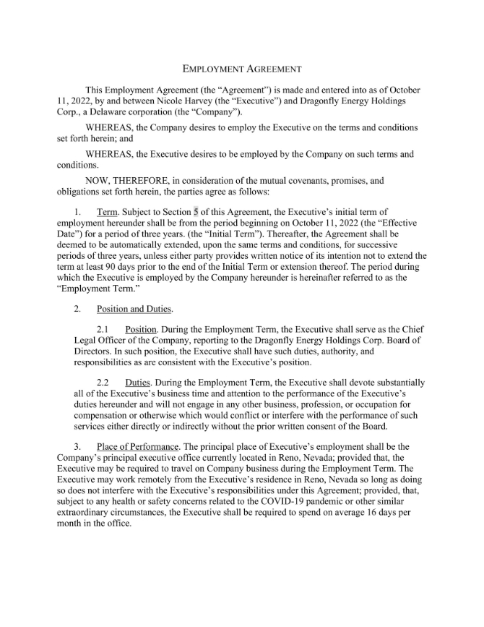

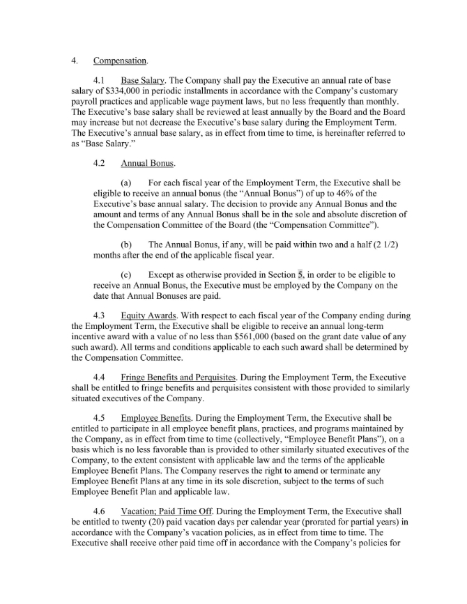

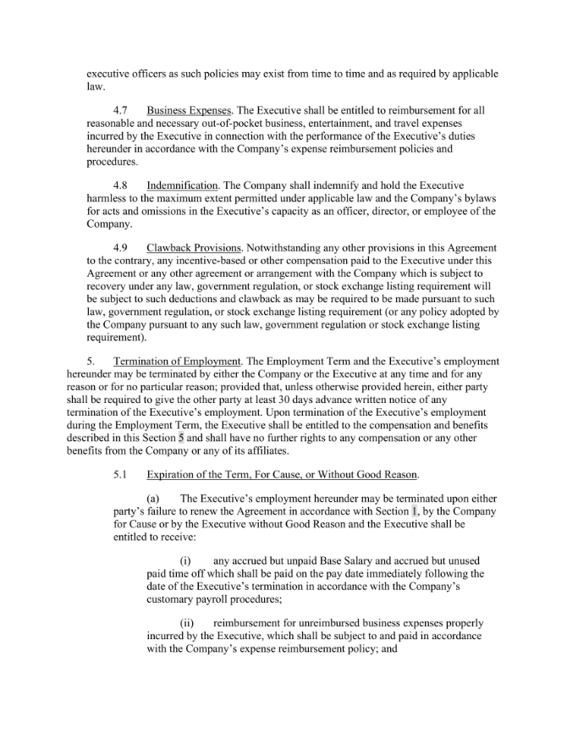

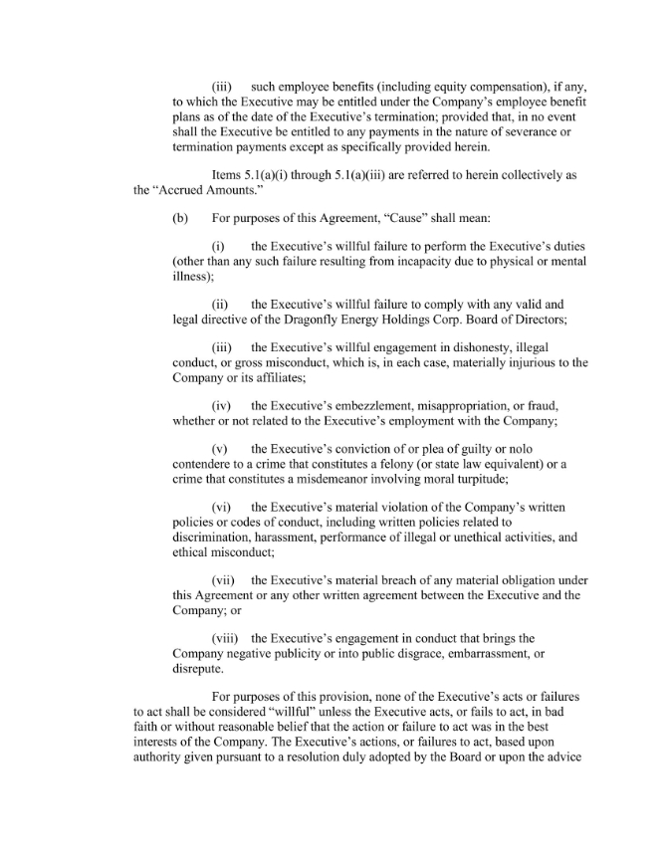

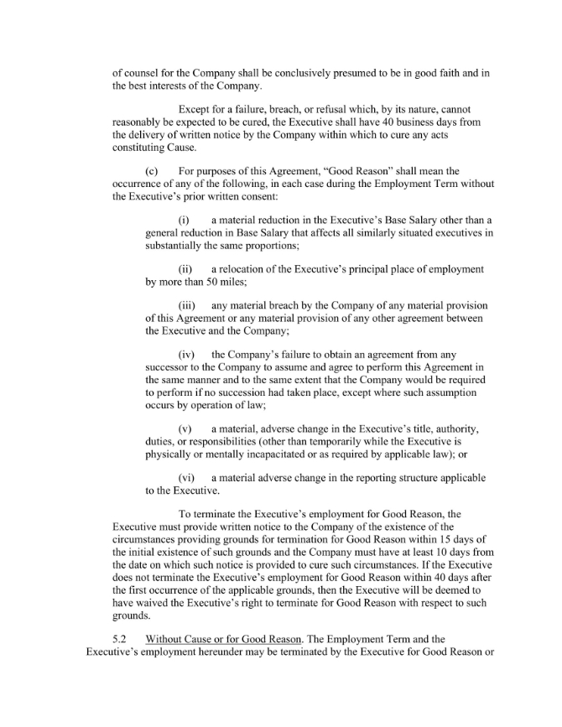

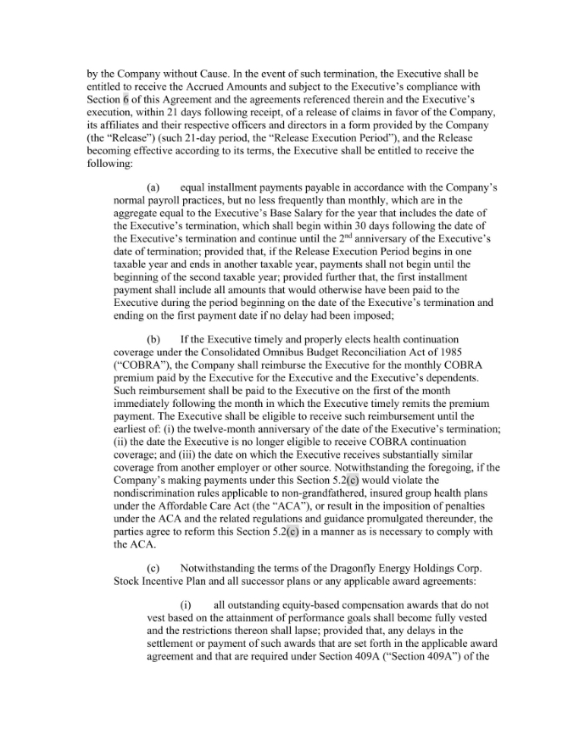

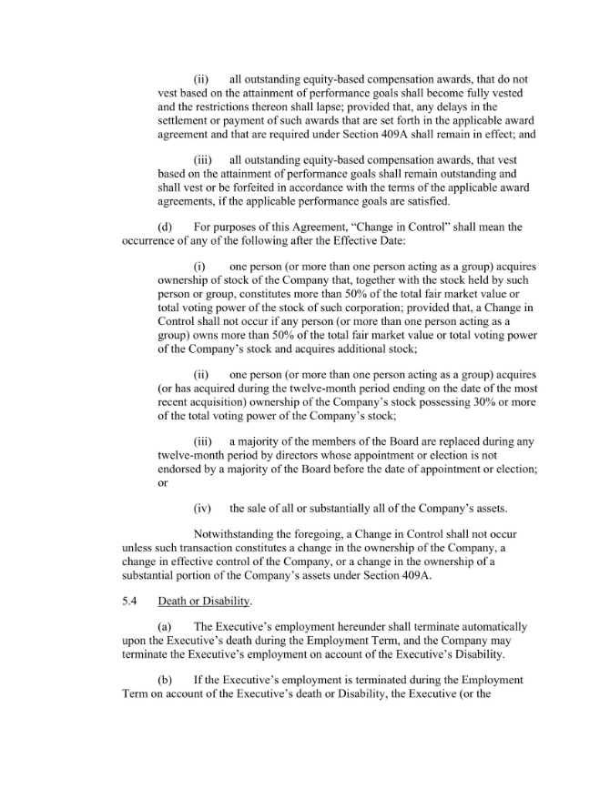

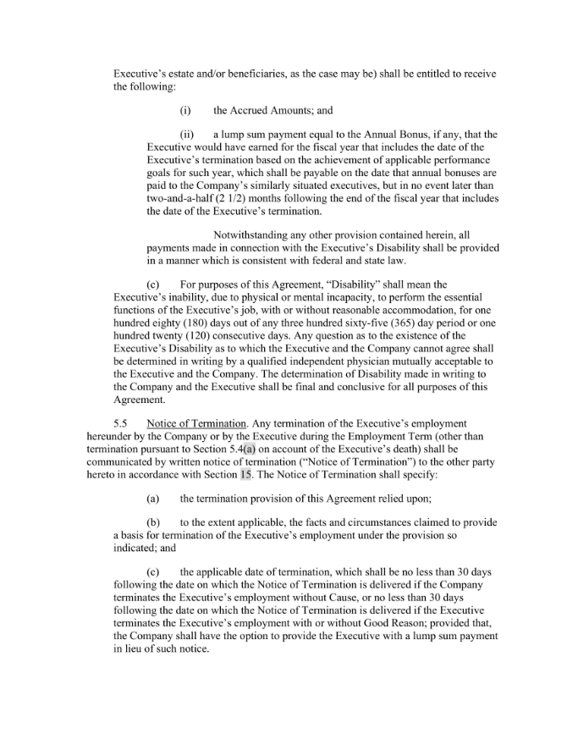

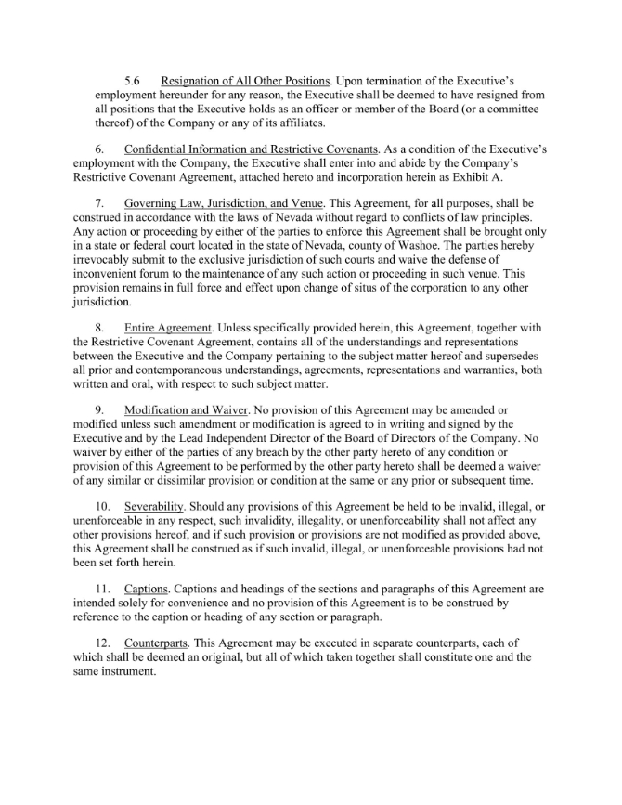

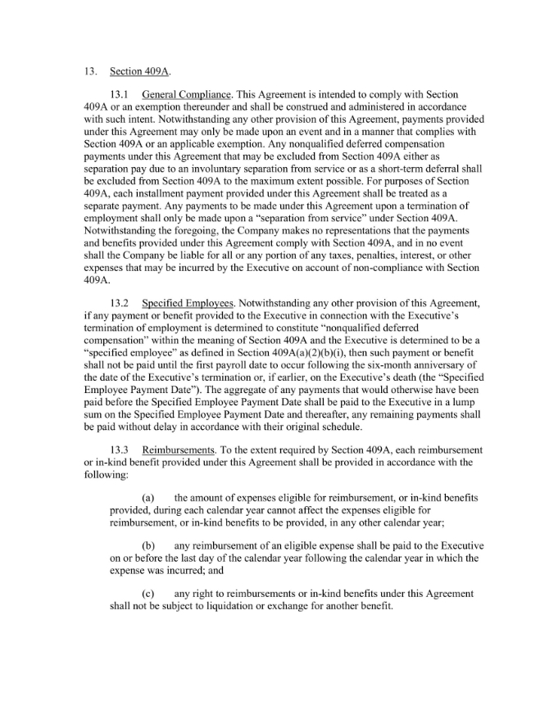

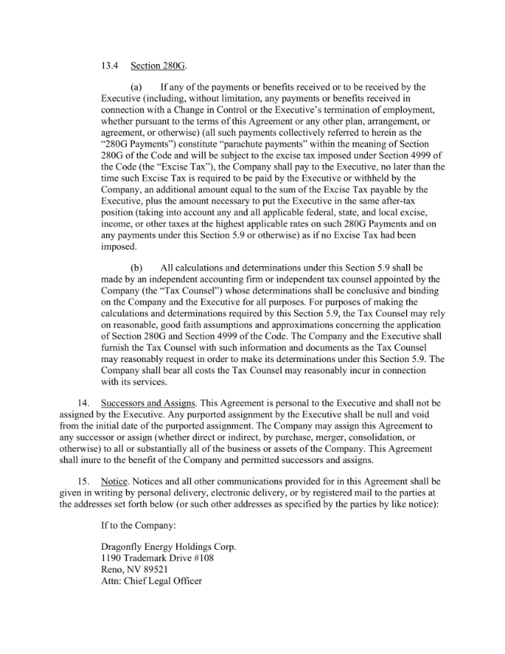

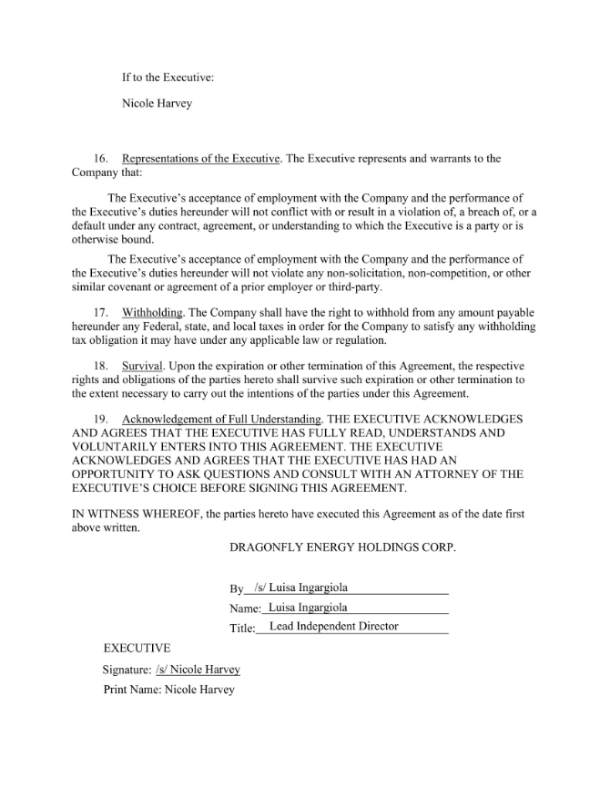

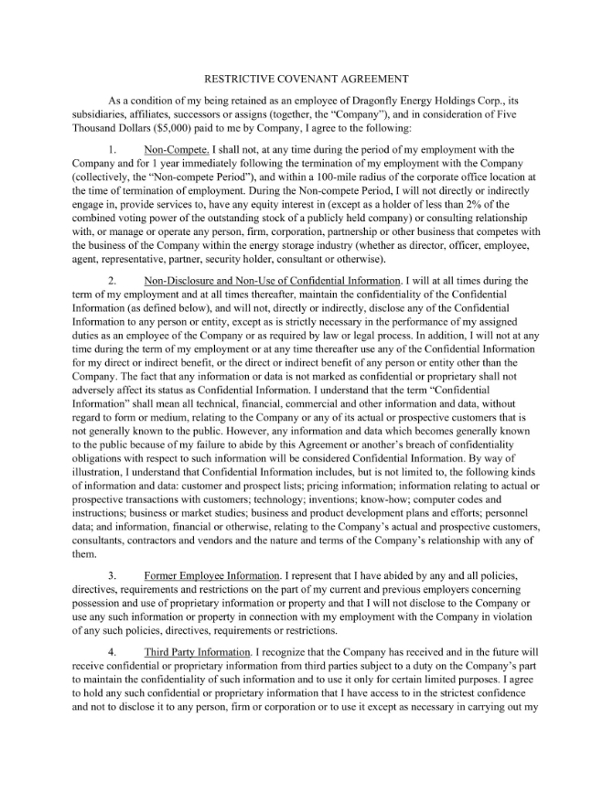

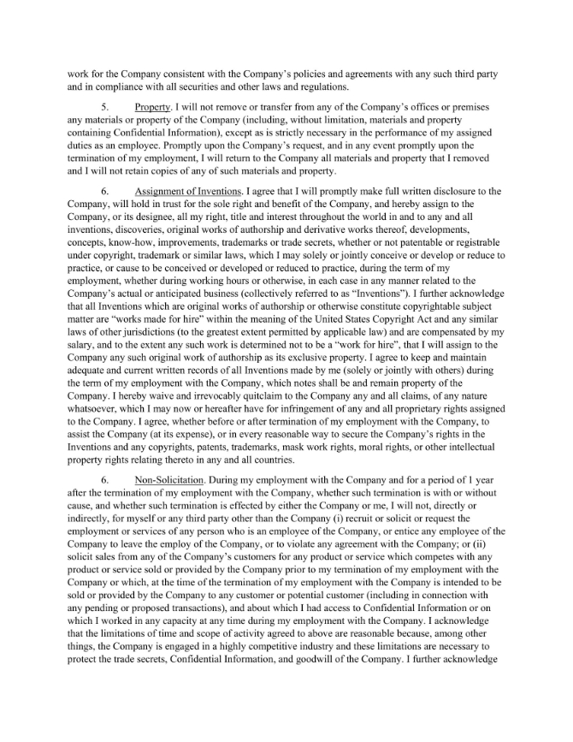

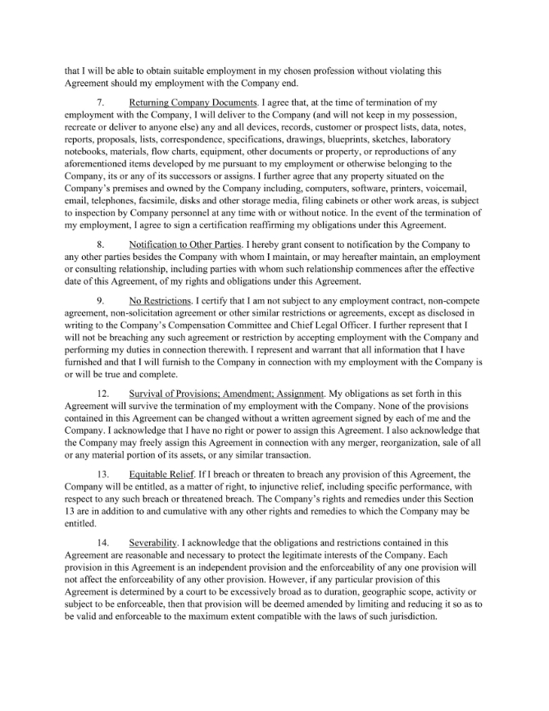

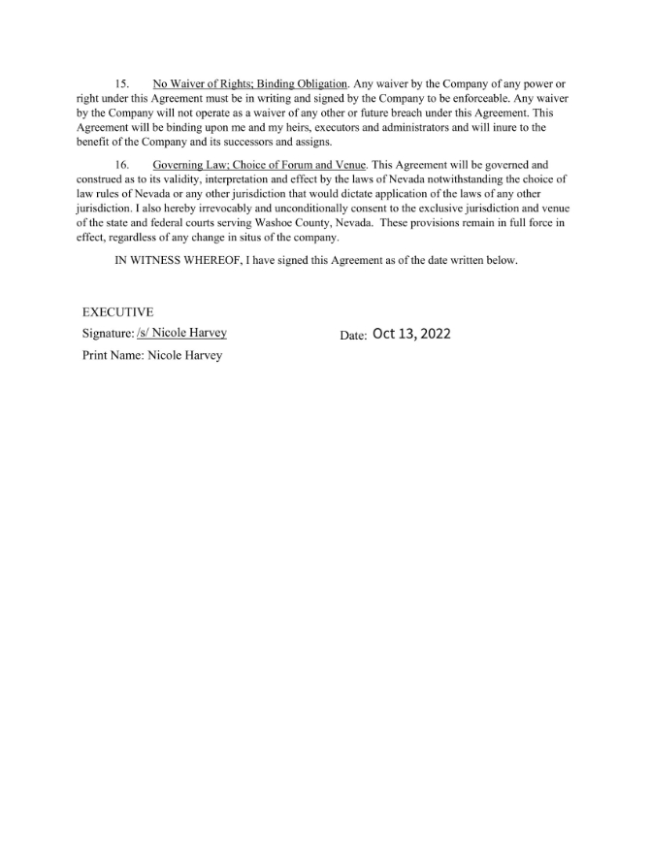

Exhibit 31.1

CERTIFICATION PURSUANT TO
RULES 13a-14(a) AND 15d-14(a) UNDER THE SECURITIES EXCHANGE ACT OF 1934,
AS ADOPTED PURSUANT TO SECTION 302 OF THE SARBANES-OXLEY ACT OF 2002

I, Denis Phares, certify that:

 | 1. | I have reviewed this amendment to the annual report on Form 10-K for the period ended December 31, 2022 of Dragonfly Energy Holdings Corp.;
 | 2. | Based on my knowledge, this report does not contain any untrue statement of a material fact or omit to state a material fact necessary to make the statements made, in light of the circumstances under which such statements were made, not misleading with respect to the period covered by this report;
 | 3. | Based on my knowledge, the financial statements, and other financial information included in this report, fairly present in all material respects the financial condition, results of operations and cash flows of the registrant as of, and for, the periods presented in this report;
 | 4. | The registrant’s other certifying officer and I are responsible for establishing and maintaining disclosure controls and procedures (as defined in Exchange Act Rules 13a-15(e) and 15d-15(e)) and internal control over financial reporting (as defined in the Exchange Act Rules 13a-15(f) and 15d-15(f)) for the registrant and have:
 |  | a) | Designed such disclosure controls and procedures, or caused such disclosure controls and procedures to be designed under our supervision, to ensure that material information relating to the registrant, including its consolidated subsidiaries, is made known to us by others within those entities, particularly during the period in which this report is being prepared;
 |  | b) | Designed such internal control over financial reporting, or caused such internal control over financial reporting to be designed under our supervision, to provide reasonable assurance regarding the reliability of financial reporting and the preparation of financial statements for external purposes in accordance with generally accepted accounting principles; ;
 |  | c) | Evaluated the effectiveness of the registrant’s disclosure controls and procedures and presented in this report our conclusions about the effectiveness of the disclosure controls and procedures, as of the end of the period covered by this report based on such evaluation; and
 |  | d) | Disclosed in this report any change in the registrant’s internal control over financial reporting that occurred during the registrant’s most recent fiscal quarter (the registrant’s fourth fiscal quarter in the case of an annual report) that has materially affected, or is reasonably likely to materially affect, the registrant’s internal control over financial reporting; and
 | 5. | The registrant’s other certifying officer(s) and I have disclosed, based on our most recent evaluation of internal control over financial reporting, to the registrant’s auditors and the audit committee of the registrant’s Board of Directors (or persons performing the equivalent functions):
 |  | a) | All significant deficiencies and material weaknesses in the design or operation of internal control over financial reporting which are reasonably likely to adversely affect the registrant’s ability to record, process, summarize and report financial information; and
 |  | b) | Any fraud, whether or not material, that involves management or other employees who have a significant role in the registrant’s internal control over financial reporting.

Date: May 1, 2023
/s/ Denis Phares
Denis Phares
Chief Executive Officer
(Principal Executive Officer)

Exhibit 31.2

CERTIFICATION PURSUANT TO
RULES 13a-14(a) AND 15d-14(a) UNDER THE SECURITIES EXCHANGE ACT OF 1934,
AS ADOPTED PURSUANT TO SECTION 302 OF THE SARBANES-OXLEY ACT OF 2002

I, John Marchetti, certify that:

 | 1. | I have reviewed this amendment to the annual report on Form 10-K for the period ended December 31, 2022 of Dragonfly Energy Holdings Corp.;
 | 2. | Based on my knowledge, this report does not contain any untrue statement of a material fact or omit to state a material fact necessary to make the statements made, in light of the circumstances under which such statements were made, not misleading with respect to the period covered by this report;
 | 3. | Based on my knowledge, the financial statements, and other financial information included in this report, fairly present in all material respects the financial condition, results of operations and cash flows of the registrant as of, and for, the periods presented in this report;
 | 4. | The registrant’s other certifying officer and I are responsible for establishing and maintaining disclosure controls and procedures (as defined in Exchange Act Rules 13a-15(e) and 15d-15(e)) and internal control over financial reporting (as defined in the Exchange Act Rules 13a-15(f) and 15d-15(f)) for the registrant and have:
 |  | a) | Designed such disclosure controls and procedures, or caused such disclosure controls and procedures to be designed under our supervision, to ensure that material information relating to the registrant, including its consolidated subsidiaries, is made known to us by others within those entities, particularly during the period in which this report is being prepared;
 |  | b) | Designed such internal control over financial reporting, or caused such internal control over financial reporting to be designed under our supervision, to provide reasonable assurance regarding the reliability of financial reporting and the preparation of financial statements for external purposes in accordance with generally accepted accounting principles;
 |  | c) | Evaluated the effectiveness of the registrant’s disclosure controls and procedures and presented in this report our conclusions about the effectiveness of the disclosure controls and procedures, as of the end of the period covered by this report based on such evaluation; and
 |  | d) | Disclosed in this report any change in the registrant’s internal control over financial reporting that occurred during the registrant’s most recent fiscal quarter (the registrant’s fourth fiscal quarter in the case of an annual report) that has materially affected, or is reasonably likely to materially affect, the registrant’s internal control over financial reporting; and
 | 5. | The registrant’s other certifying officer and I have disclosed, based on our most recent evaluation of internal control over financial reporting, to the registrant’s auditors and the audit committee of the registrant’s Board of Directors (or persons performing the equivalent functions):
 |  | a) | All significant deficiencies and material weaknesses in the design or operation of internal control over financial reporting which are reasonably likely to adversely affect the registrant’s ability to record, process, summarize and report financial information; and
 |  | b) | Any fraud, whether or not material, that involves management or other employees who have a significant role in the registrant’s internal control over financial reporting.

Date: May 1, 2023
/s/ John Marchetti
John Marchetti
Chief Financial Officer
(Principal Financial Officer)

