UNITED STATES

SECURITIES AND EXCHANGE COMMISSION
Washington, D.C. 20549

FORM 8-K

CURRENT REPORT

Pursuant to Section 13 or 15(d) of the Securities Exchange Act of 1934

Date of Report (Date of earliest event reported): June 5, 2026

DRAGONFLY ENERGY HOLDINGS CORP.

(Exact name of registrant as specified in its charter)

Nevada | 001-40730 | 85-1873463
(State or other jurisdiction | (Commission | (IRS Employer
of incorporation) | File Number) | Identification No.)
12915 Old Virginia Road
Reno, Nevada |  | 89521
(Address of principal executive offices) |  | (Zip Code)

Registrant’s telephone number, including area code: (775) 622-3448

N/A

(Former name or former address, if changed since last report.)

Check the appropriate box below if the Form 8-K filing is intended to simultaneously satisfy the filing obligation of the registrant under any of the following provisions:

- Written communications pursuant to Rule 425 under the Securities Act (17 CFR 230.425)

- Soliciting material pursuant to Rule 14a-12 under the Exchange Act (17 CFR 240.14a-12)

- Pre-commencement communications pursuant to Rule 14d-2(b) under the Exchange Act (17 CFR 240.14d-2(b))

- Pre-commencement communications pursuant to Rule 13e-4(c) under the Exchange Act (17 CFR 240.13e-4(c)) Securities registered pursuant to Section 12(b) of the Act:

Title of each class |  | Trading Symbol(s) |  | Name of each exchange on which registered
Common Stock, par value $0.0001 per share |  | DFLI |  | The Nasdaq Capital Market
Redeemable warrants, exercisable for common stock |  | DFLIW |  | The Nasdaq Capital Market

Indicate by check mark whether the registrant is an emerging growth company as defined in Rule 405 of the Securities Act of 1933 (17 CFR §230.405) or Rule 12b-2 of the Securities Exchange Act of 1934 (17 CFR §240.12b-2).

Emerging growth company ☒

If an emerging growth company, indicate by check mark if the registrant has elected not to use the extended transition period for complying with any new or revised financial accounting standards provided pursuant to Section 13(a) of the Exchange Act. ☐

Item 5.03 Amendments to Articles of Incorporation or Bylaws; Change in Fiscal Year.

Amendment to Articles of Incorporation

On June 5, 2026, Dragonfly Energy Holdings Corp. (the “Company”) filed a Certificate of Amendment to the Company’s Articles of Incorporation, as amended from time to time (as amended, the “Articles of Incorporation”), with the Secretary of State of the State of Nevada (the “Certificate of Amendment”) to update the Company’s registered agent and registered office. The Certificate of Amendment became effective upon filing.

A copy of the Certificate of Amendment is attached hereto as Exhibit 3.1 and is incorporated by reference herein.

Withdrawal of Series A Certificate of Designation

As previously disclosed, on February 26, 2025, the Company filed a Certificate of Designation of the Powers, Preferences and Relative, Participating, Optional and Other Restrictions of Series A Convertible Preferred Stock of the Company (the “Certificate of Designation”) with the Secretary of State of the State of Nevada, pursuant to which the Company designated 5,000 shares of preferred stock as Series A Convertible Preferred Stock (the “Series A Preferred Stock”).

On June 5, 2026, the Company filed a Withdrawal of Designation relating to the Series A Preferred Stock (the “Withdrawal of Designation”) with the Secretary of State of the State of Nevada. At the time of the filing of the Withdrawal of Designation, no shares of Series A Preferred Stock were issued or outstanding. The Withdrawal of Designation became effective upon filing and eliminated from the Company’s Articles of Incorporation all matters set forth in the previously filed Certificate of Designation with respect to the previously designated Series A Preferred Stock.

A copy of the Withdrawal of Designation is attached hereto as Exhibit 3.2 and is incorporated herein by reference.

Item 9.01. Financial Statements and Exhibits.

(d) Exhibits.

Exhibit

No. Description
3.1 Certificate of Amendment to the Articles of Incorporation, as amended, of Dragonfly Energy Holdings Corp., as filed with the Secretary of State of the State of Nevada, dated June 5, 2026.
3.2 Certificate, Amendment or Withdrawal of Designation, relating to the Series A Convertible Preferred Stock, as filed with the Secretary of State of Nevada, dated June 5, 2026.

104 Cover Page Interactive Data File (embedded within the Inline XBRL document).

Signature

Pursuant to the requirements of the Securities Exchange Act of 1934, the registrant has duly caused this report to be signed on its behalf by the undersigned hereunto duly authorized.

 | DRAGONFLY ENERGY HOLDINGS CORP.
Dated: June 8, 2026 | By: | /s/ Denis Phares
 | Name: | Denis Phares
 | Title: | Chief Executive Officer,
 |  | Interim Chief Financial Officer and President

Exhibit 3.1
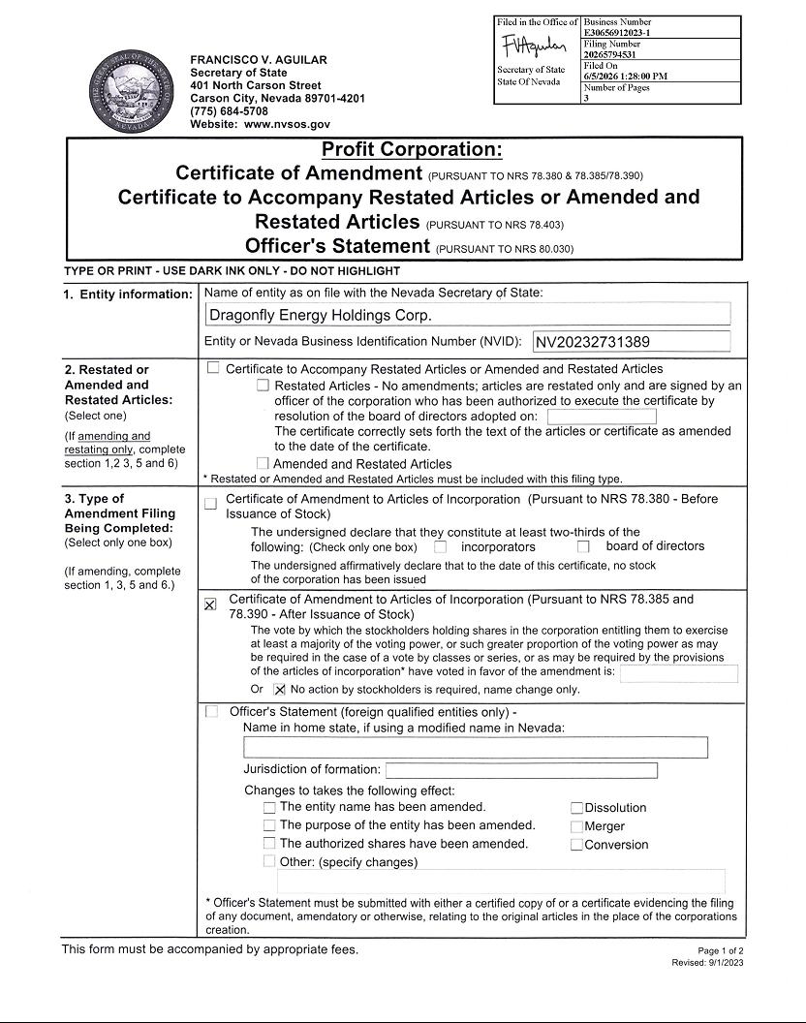

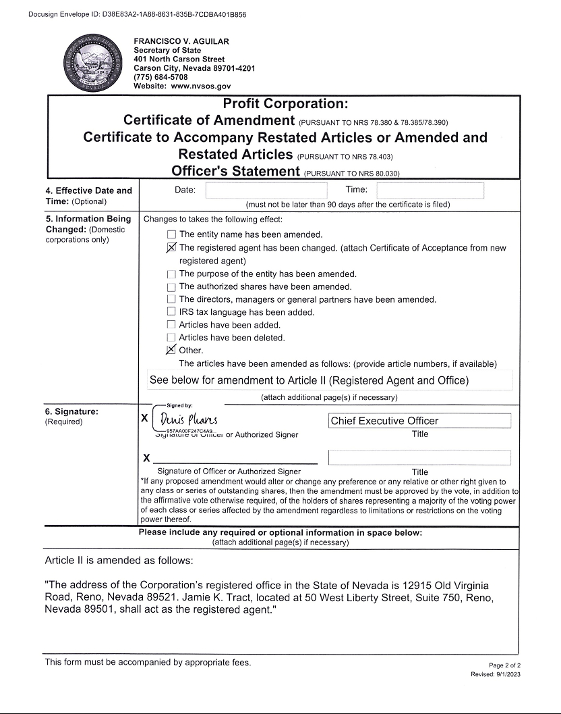

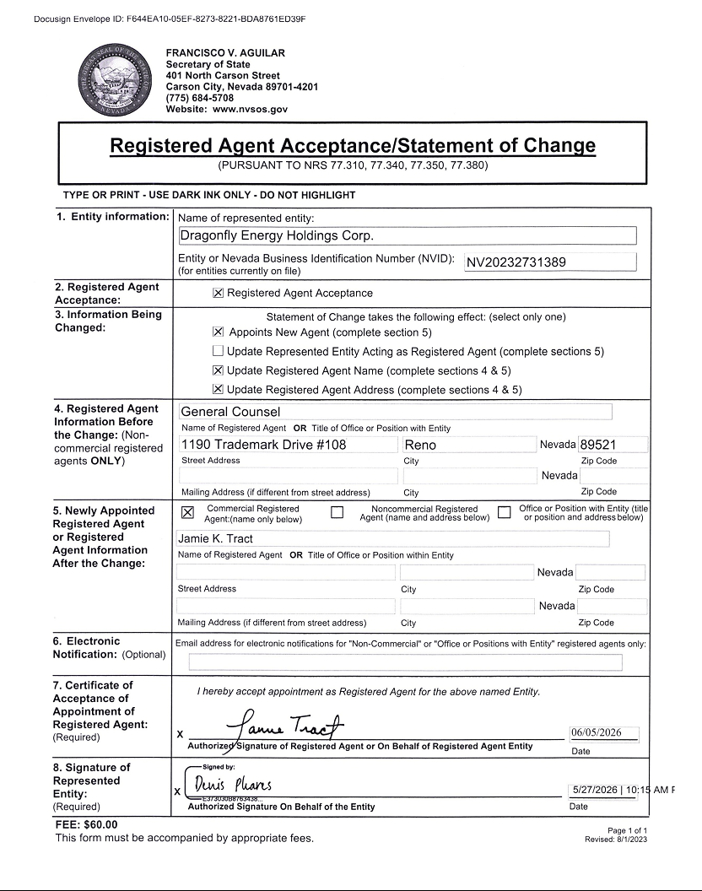

Exhibit 3.2


