Filed by Chardan NexTech Acquisition 2 Corp. pursuant to

Rule 425 under the Securities Act of 1933

and deemed filed pursuant to Rule 14a-12

under the Securities Exchange Act of 1934

Subject Company: Chardan NexTech Acquisition 2 Corp.

Commission File No.: 001-40730
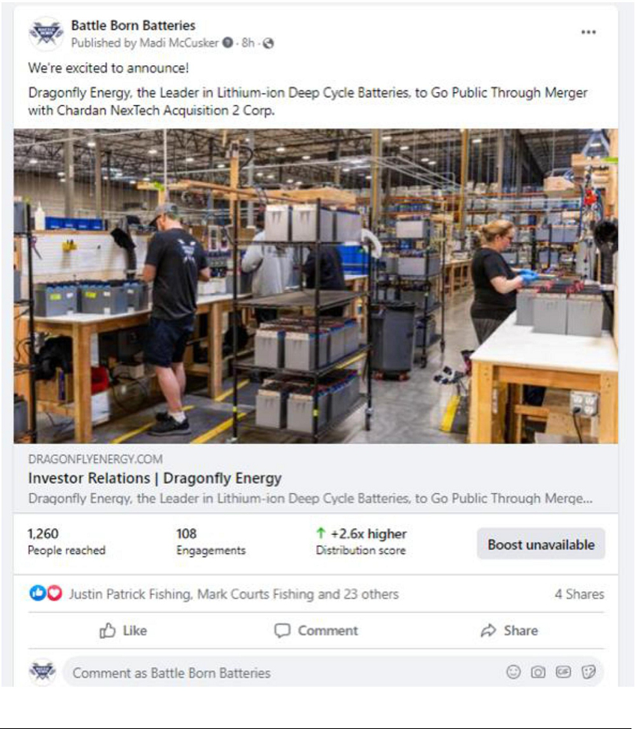

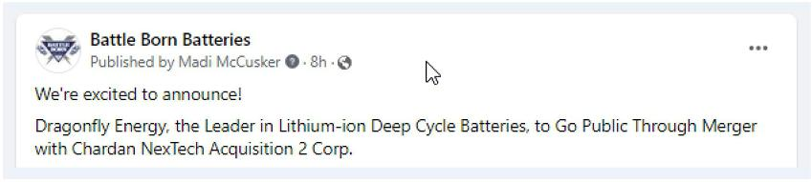

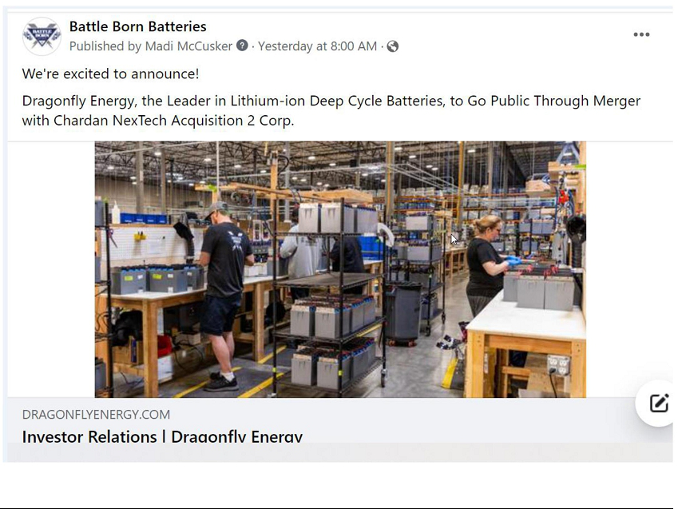

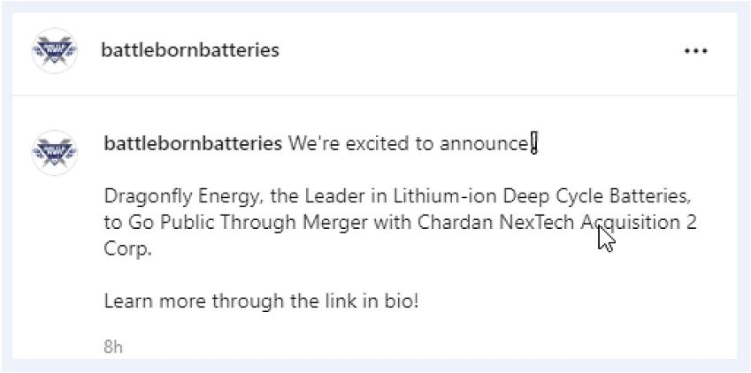

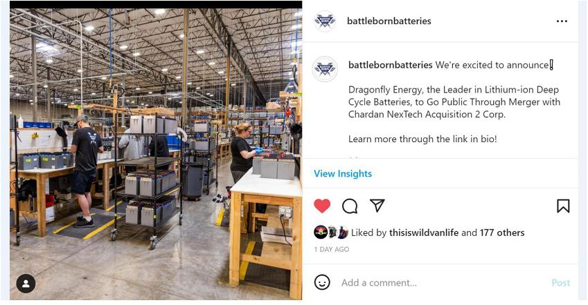

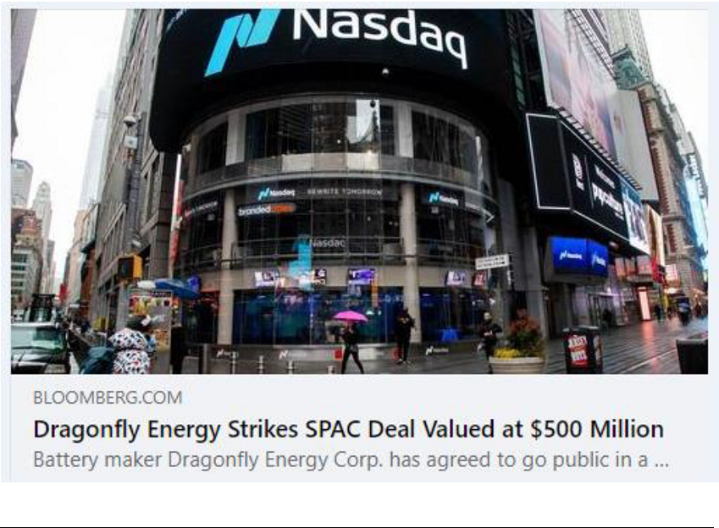

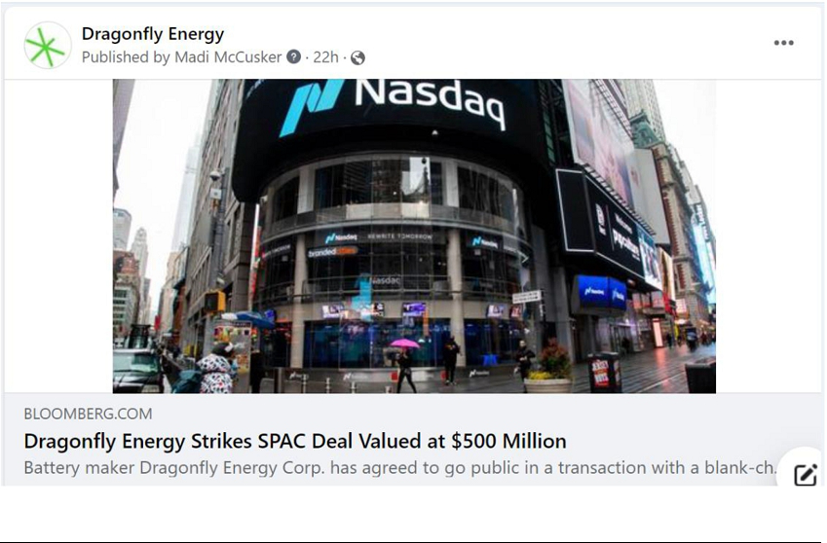

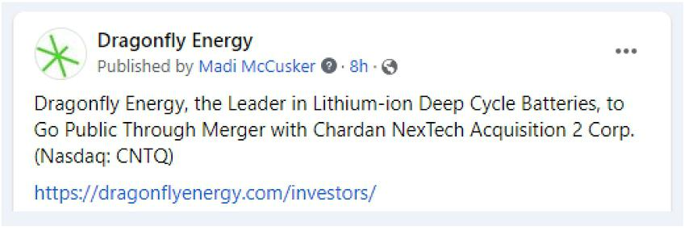

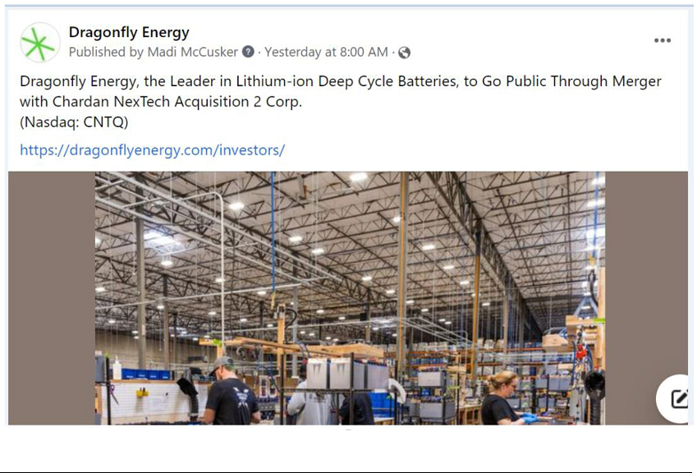

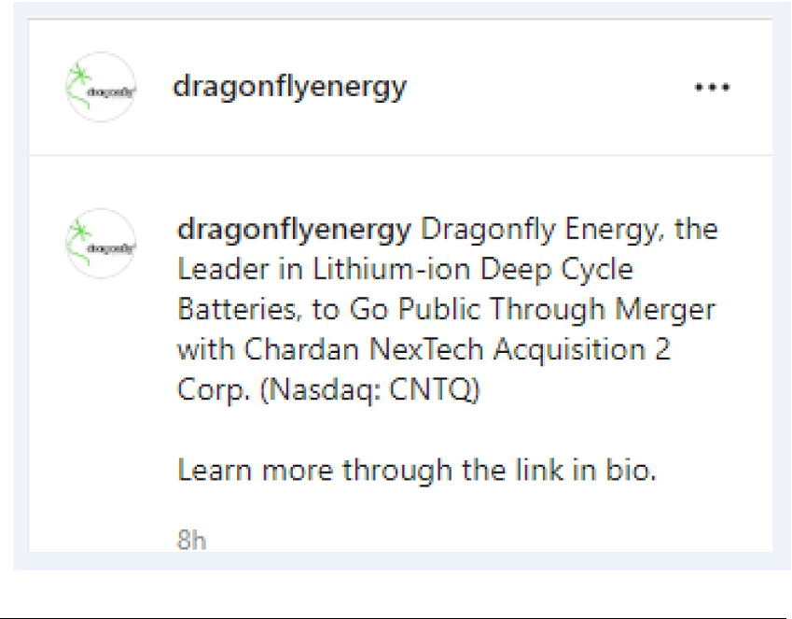

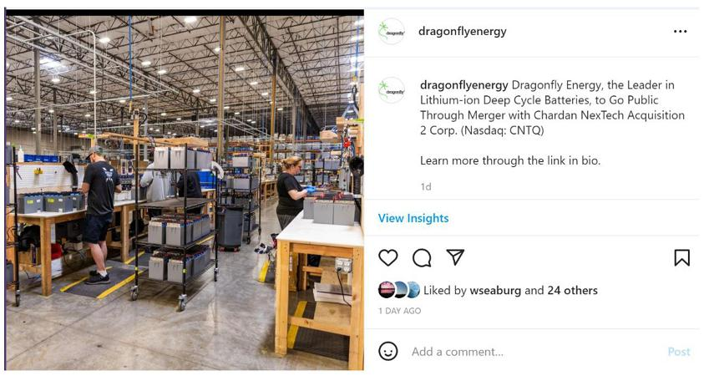

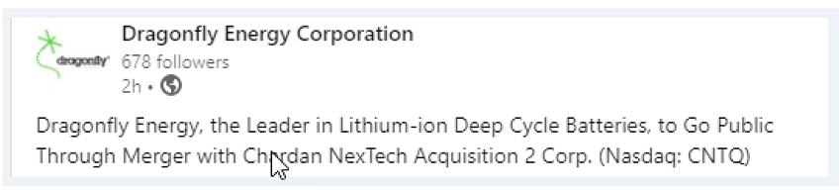

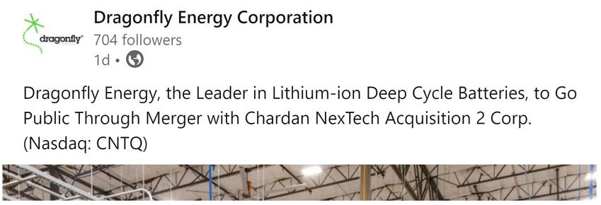

Forward-Looking Statements

This communication contains certain “forward-looking statements” within the meaning of the United States Private Securities Litigation Reform Act of 1995, Section 27A of the Securities Act of 1933, as amended (the “Securities Act”) and Section 21E of the Securities Exchange Act of 1934, as amended, including certain financial forecasts and projections. All statements other than statements of historical fact contained in this communication, including statements as to the transactions contemplated by the business combination and related agreements, future results of operations and financial position, revenue and other metrics, planned products and services, business strategy and plans, objectives of management for future operations of Dragonfly, market size and growth opportunities, competitive position and technological and market trends, are forward-looking statements. Some of these forward-looking statements can be identified by the use of forward-looking words, including “may,” “should,” “expect,” “intend,” “will,” “estimate,” “anticipate,” “believe,” “predict,” “plan,” “targets,” “projects,” “could,” “would,” “continue,” “forecast” or the negatives of these terms or variations of them or similar expressions. All forward-looking statements are subject to risks, uncertainties, and other factors (some of which are beyond the control of Dragonfly or CNTQ) which could cause actual results to differ materially from those expressed or implied by such forward-looking statements. All forward-looking statements are based upon estimates, forecasts and assumptions that, while considered reasonable by CNTQ and its management, and Dragonfly and its management, as the case may be, are inherently uncertain and many factors may cause the actual results to differ materially from current expectations which include, but are not limited to:

- the occurrence of any event, change or other circumstances that could give rise to the termination of the definitive merger agreement with respect to the business combination; 2) the outcome of any legal proceedings that may be instituted against Dragonfly, CNTQ, the combined company or others following the announcement of the business combination and the transactions contemplated thereby; 3) the inability to complete the business combination due to the failure to obtain approval of the stockholders of CNTQ or Dragonfly, or to satisfy other conditions to closing the business combination; 4) changes to the proposed structure of the business combination that may be required or appropriate as a result of applicable laws or regulations or as a condition to obtaining regulatory approval of the business combination; 5) the ability to meet Nasdaq's listing standards following the consummation of the business combination;

- the risk that the business combination disrupts current plans and operations of Dragonfly as a result of the announcement and consummation of the business combination; 7) the inability to recognize the anticipated benefits of the business combination; 8) ability of Dragonfly to successfully increase market penetration into its target markets; 9) the addressable markets that Dragonfly intends to target do not grow as expected; 10) the loss of any key executives; 11) the loss of any relationships with key suppliers including suppliers in China; 12) the loss of any relationships with key customers; 13) the inability to protect Dragonfly’s patents and other intellectual property; 14) the failure to successfully optimize solid state cells or to produce commercially viable solid state cells in a timely manner or at all, or to scale to mass production; 15) costs related to the business combination; 16) changes in applicable laws or regulations; 17) the possibility that Dragonfly or the combined company may be adversely affected by other economic, business and/or competitive factors; 18) Dragonfly’s estimates of its growth and projected financial results for 2022 and 2023 and meeting or satisfying the underlying assumptions with respect thereto; 19) the risk that the business combination may not be completed in a timely manner or at all, which may adversely affect the price of CNTQ’s securities; 20) the risk that the transaction may not be completed by CNTQ’s business combination deadline (as may be extended pursuant to CNTQ’s governing documents); 21) the impact of the novel coronavirus disease pandemic, including any mutations or variants thereof, and its effect on business and financial conditions; 22) inability to complete the PIPE investment, the term loan and equity line (ChEF) in connection with the business combination; and 23) other risks and uncertainties set forth in the sections entitled “Risk Factors” and “Cautionary Note Regarding Forward-Looking Statements” in CNTQ’s Form S-1 (File Nos. 333-252449 and 333-253016), Annual Report on Form 10-K for the year ended December 31, 2021 and registration statement on Form S-4 with the SEC, which will include a document that serves as a prospectus and proxy statement of CNTQ, referred to as a proxy statement/prospectus and other documents filed by CNTQ from time to time with the SEC. These filings identify and address other important risks and uncertainties that could cause actual events and results to differ materially from those contained in the forward-looking statements. Nothing in this communication should be regarded as a representation by any person that the forward-looking statements set forth herein will be achieved or that any of the contemplated results of such forward looking statements will be achieved. You should not place undue reliance on forward-looking statements, which speak only as of the date they are made. Neither CNTQ nor Dragonfly gives any assurance that either CNTQ or Dragonfly or the combined company will achieve its expected results. Neither CNTQ nor Dragonfly undertakes any duty to update these forward-looking statements, except as otherwise required by law. For additional information, see “Risk Considerations” in the investor presentation, which will be provided in a Current Report on Form 8-K to be filed by CNTQ with the SEC and available at www.sec.gov.

Additional Information and Where to Find It

This communication relates to a proposed transaction between CNTQ and Dragonfly. CNTQ intends to file a registration statement on Form S-4 with the SEC, which will include a document that serves as a prospectus and proxy statement of CNTQ, referred to as a proxy statement/prospectus. A proxy statement/prospectus will be sent to all CNTQ stockholders. CNTQ also will file other documents regarding the proposed transaction with the SEC. Before making any voting decision, investors and security holders of CNTQ are urged to read the registration statement, the proxy statement/prospectus and all other relevant documents filed or that will be filed with the SEC in connection with the proposed transaction as they become available because they will contain important information about the proposed transaction.

Investors and security holders will be able to obtain free copies of the registration statement, the proxy statement/prospectus and all other relevant documents filed or that will be filed with the SEC by CNTQ through the website maintained by the SEC at www.sec.gov.

The documents filed by CNTQ with the SEC also may be obtained by contacting Chardan NexTech Acquisition 2 Corp. at 17 State Street, 21st Floor, New York, New York 10004, or by calling (646) 465-9001.

NEITHER THE SEC NOR ANY STATE SECURITIES REGULATORY AGENCY HAS APPROVED OR DISAPPROVED THE TRANSACTIONS DESCRIBED IN THIS COMMUNICATION, PASSED UPON THE MERITS OR FAIRNESS OF THE BUSINESS COMBINATION OR RELATED TRANSACTIONS OR PASSED UPON THE ADEQUACY OR ACCURACY OF THE DISCLOSURE IN THIS COMMUNICATION. ANY REPRESENTATION TO THE CONTRARY CONSTITUTES A CRIMINAL OFFENSE.

Participants in the Solicitation

Dragonfly, CNTQ and certain of their respective directors, executive officers and other members of management and employees may, under SEC rules, be deemed to be participants in the solicitation of proxies from CNTQ’s shareholders in connection with the proposed business combination. A list of the names of such persons and information regarding their interests in the proposed business combination will be contained in the proxy statement/prospectus when available. You may obtain free copies of these documents free of charge by directing a written request to CNTQ or Dragonfly. The definitive proxy statement will be mailed to CNTQ’s shareholders as of a record date to be established for voting on the proposed business combination when it becomes available.

No Offer or Solicitation

This communication is and the information contained therein are not intended to and does not constitute an offer to sell or the solicitation of an offer to buy, sell or solicit any securities or any proxy, vote or approval, nor shall there be any sale of securities in any jurisdiction in which such offer, solicitation or sale would be unlawful prior to registration or qualification under the securities laws of any such jurisdiction. No offer of securities shall be deemed to be made except by means of a prospectus meeting the requirements of Section 10 of the Securities Act or an exemption therefrom.

