UNITED STATES

SECURITIES AND EXCHANGE COMMISSION
Washington, D.C. 20549

FORM 8-K

CURRENT REPORT

Pursuant to Section 13 or 15(d) of

the Securities Exchange Act of 1934

Date of Report (Date of earliest event reported): November 29, 2023

DRAGONFLY ENERGY HOLDINGS CORP.

(Exact name of registrant as specified in its charter)

Nevada |  |  | 001-40730 |  |  |  | 85-1873463
(State or other jurisdiction |  |  | (Commission |  |  |  | (IRS Employer
of incorporation) |  |  | File Number) |  |  |  | Identification No.)
1190 Trademark Drive, #108
Reno, Nevada |  |  |  |  |  |  | 89521
(Address of principal executive offices) |  |  |  |  |  |  | (Zip Code)

(775) 622 – 3448

(Registrant’s telephone number, including area code)

N/A

(Former name or former address, if changed since last report.)

Check the appropriate box below if the Form 8-K filing is intended to simultaneously satisfy the filing obligation of the registrant under any of the following provisions:

- Written communications pursuant to Rule 425 under the Securities Act (17 CFR 230.425)

- Soliciting material pursuant to Rule 14a-12 under the Exchange Act (17 CFR 240.14a-12)

- Pre-commencement communications pursuant to Rule 14d-2(b) under the Exchange Act (17 CFR 240.14d-2(b))

- Pre-commencement communications pursuant to Rule 13e-4(c) under the Exchange Act (17 CFR 240.13e-4(c)) Securities registered pursuant to Section 12(b) of the Act:

 |  |  |  | Name of each exchange
Title of each class |  | Trading Symbol(s) |  | on which registered
Common Stock, par value $0.0001 |  | DFLI |  | The Nasdaq Global Market
Redeemable warrants, exercisable for common stock at an |  | DFLIW |  | The Nasdaq Capital Market
exercise price of $11.50 per share, subject to adjustment

Indicate by check mark whether the registrant is an emerging growth company as defined in Rule 405 of the Securities Act of 1933 (17 CFR §230.405) or Rule 12b-2 of the Securities Exchange Act of 1934 (17 CFR §240.12b-2).

Emerging growth company ☒

If an emerging growth company, indicate by check mark if the registrant has elected not to use the extended transition period for complying with any new or revised financial accounting standards provided pursuant to Section 13(a) of the Exchange Act. ☐

Item 5.03 Amendments to Articles of Incorporation or Bylaws; Changes in Fiscal Year.

As described under Proposal 2 of Item 5.07 of this Current Report, on November 29, 2023, the stockholders of Dragonfly Energy Holdings Corp. (the “Company”) voted at the Company’s Annual Meeting of Stockholders (the “Annual Meeting”) to approve an amendment to the Company’s articles of incorporation (the “Articles of Incorporation”), to increase the number of authorized shares of common stock, par value of $0.0001 per share (“Common Stock”) from 170,000,000 shares to 250,000,000 shares. The Articles of Incorporation were amended by deleting Article 4 thereof in its entirety and inserting the following:

NUMBER OF SHARES WITH PAR VALUE:

250,000,000 COMMON - $0.0001 PAR VALUE

5,000,000 PREFERRED - $0.0001 PAR VALUE

The Certificate of Amendment to the Articles of Incorporation as filed with the Secretary of State of the State of Nevada on November 29, 2023 is attached to this Current Report as Exhibit 3.1 and is incorporated herein by reference.

Item 5.07 Submission of Matters to a Vote of Security Holders.

On November 29, 2023, the Company held its Annual Meeting. The matters voted on at the Annual Meeting were: (i) the election of two Class A directors to hold office until the 2026 annual meeting of stockholders; (ii) the adoption of an amendment to the Articles of Incorporation to increase the number of shares of the Company’s Common Stock authorized for issuance thereunder from 170,000,000 shares to 250,000,000 shares (“Proposal 2”); and

- the adjournment of the Annual Meeting in the event that the number of shares of Common Stock present or represented by proxy at the Annual Meeting and voting “FOR” the adoption of Proposal 2 were insufficient.

The voting results for each item of business voted upon at the Annual Meeting were as follows:

- The votes cast with respect to the proposal to elect the following Class A directors, Rick Parod and Karina Montilla Edmonds, as directors of the Company to hold office until the 2026 annual meeting and until his or her successor has been duly elected and qualified, or, if sooner, until the director’s death, resignation or removal, were as follows:

 |  |  |  |  | BROKER
 | FOR |  | WITHHELD |  | NON-VOTES
Rick Parod | 40,918,637 |  | 608,452 |  | 6,791,062
Karina Montilla Edmonds | 40,272,566 |  | 1,317,523 |  | 6,791,062

The stockholders elected each nominee to serve as a Class A director of the Company.

- The votes cast with respect to the proposal to adopt an amendment to the Articles of Incorporation to increase the number of shares of Common Stock authorized for issuance thereunder from 170,000,000 shares to 250,000,000 shares were as follows:

FOR |  | AGAINST |  | ABSTAIN
42,863,626 |  | 5,400,169 |  | 117,356

The stockholders approved the proposal to adopt the amendment to the Articles of Incorporation.

- The votes cast with respect to the proposal to adjourn the Annual Meeting in the event that the number of shares of Common Stock present or represented by proxy at the Annual Meeting and voting “FOR” the adoption of Proposal 2 were insufficient were as follows:

FOR |  | AGAINST |  | ABSTAIN
43,433,652 |  | 4,625,573 |  | 321,926

The stockholders approved the adjournment of the Annual Meeting based on the votes set forth above; however, an adjournment was not needed as Proposal 2 received a sufficient number of votes for approval.

Item 9.01. Financial Statements and Exhibits.

(d) Exhibits:
Exhibit No. |  | Description
3.1 |  | Certificate of Amendment to the Articles of Incorporation of Dragonfly Energy Holdings Corp., dated November 29, 2023.
104 |  | Cover Page Interactive Date File (embedded within the Inline XRBL document).

SIGNATURES

Pursuant to the requirements of the Securities Exchange Act of 1934, the registrant has duly caused this report to be signed on its behalf by the undersigned hereunto duly authorized.

DRAGONFLY ENERGY HOLDINGS CORP.

Date: November 29, 2023 By: /s/ Denis Phares

Name: Denis Phares

Title: Chief Executive Officer and

Interim Chief Financial Officer

Exhibit 3.1
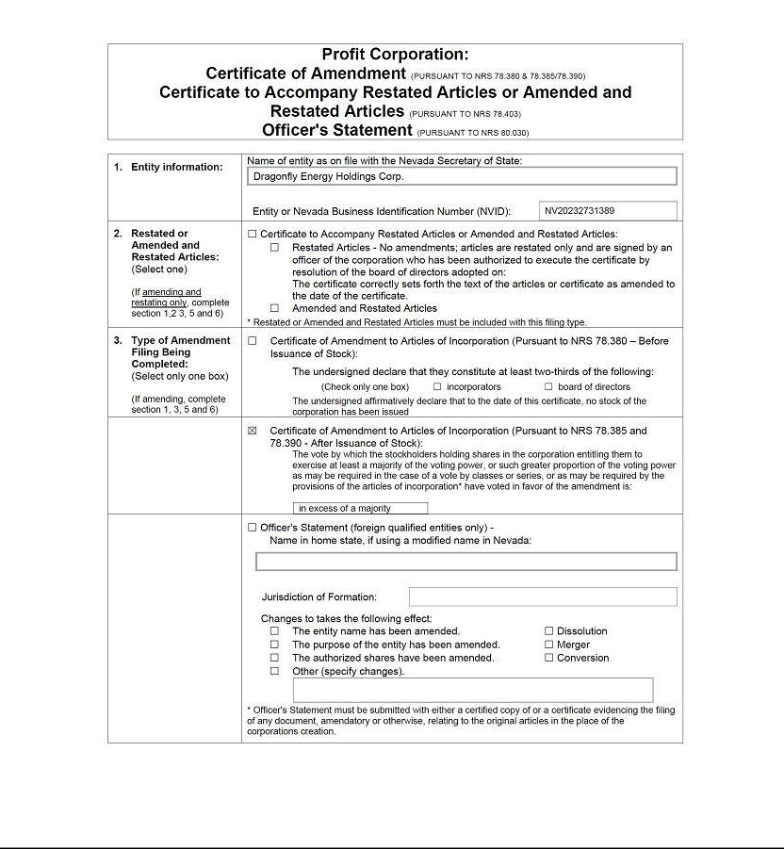

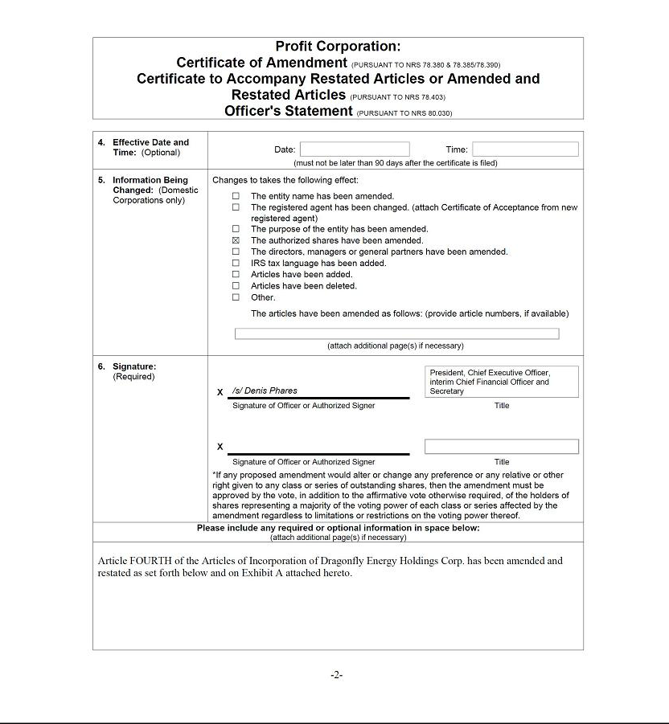

Exhibit A

DRAGONFLY ENERGY HOLDINGS CORP.

Certificate of Amendment to Articles of Incorporation (Pursuant to NRS 78.385 and 78.390 - After Issuance of Stock)

The vote by which the stockholders holding shares in the corporation entitling them to exercise at least a majority of the voting power, or such greater proportion of the voting power as may be required in the case of a vote by classes or series, or as may be required by the provisions of the articles of incorporation* have voted in favor of the amendment is: in excess of a majority.

Article FOURTH of the Articles of Incorporation of Dragonfly Energy Holdings Corp. is amended in its entirety to read as follows:

NUMBER OF SHARES WITH PAR VALUE:

250,000,000 COMMON - $0.0001 PAR VALUE

5,000,000 PREFERRED - $0.0001 PAR VALUE

